## A PROJECT REPORT ON

### TOWARDS CLOUD COMPUTING

### AND BLOCK CHAIN

### INTEGRATED APPLICATIONS

SUBMITTED BY

GUNTUPALLI GOPI CHAND (217W1A0536)

CHITALLAKA NAGALAKSHMI (217W1A0506)

UPPALA ASTITH (217W1A0524)

VANKAYALAPATI VANAJA (217W1A0525)

PAMIDI LAKSHMI PRASANN (217W1A0516)

Bachelor of Technology in

COMPUTER SCIENCE AND ENGINEERING (COMPUTER SCIENCE AND ENGINEERING)

Under The Guidance Of

K.N.B CHARI ASSISTANT PROFESSER



Department Of Computer Science and Engineering

MALINENI PERUMALLU EDUCATIONAL SOCIETY’S GROUP OF INSTITUTIONS

(Approved by AICTE & Affiliated to JNTU KAKINADA)

#### Pulladigunta (V), Guntur – 522017 2021 - 2025

MALINENI PERUMALLU EDUCATIONAL SOCIETY’S GROUP OF INSTITUTIONS

(Approved by AICTE & Affiliated to JNTU KAKINADA)

#### Pulladigunta (V), Guntur – 522017 2021 - 2025

DEPARTMENT OF COMPUTER SCIENCE AND ENGINEERING



**CERTIFICATE**

### *This is to certify that the project entitled* “ TOWARDS CLOUD COMPUTING & BLOCK CHAIN INTEGRATED APPLICATION” *bonafide work carried out by*

GUNTUPALLI GOPI CHAND (217W1A0536) CHITALLAKA NAGALAKSHMI (217W1A0506)

UPPALA ASTITHA (217W1A0524)

VANKAYALAPATI VANAJA (217W1A0525)

PAMIDI LAKSHMI PRASANNA (217W1A0516)

*B.Tech students of* ***MPES****, Affiliated to* ***JNTUK****, Kakinada in partial fulfilment of the requirements for the award of the Degree of* ***Bachelor Of Technology*** *with the specialization in* ***Computer Science And Engineering*** *during the Academic year* ***2024-2025.***

### Sig. of The Guide Sign. Of HOD

#### Viva-voice held on

**Internal Examiner External Examiner**

## MALINENI PERUMALLU EDUCATIONAL SOCIETY’S GROUP OF INSTITUTIONS

**(Approved by AICTE & Affiliated to JNTU KAKINADA)**

**Pulladigunta(V), Guntur – 522017**

## DEPARTMENT OF COMPUTER SCIENCE AND ENGINEERING

0 

## DECLARATION

We here by declare that the project work entitled “TOWARDS CLOUD COMPIUTING & BLOCK CHAIN INTEGRATED APPLICATIONS” is entirely my original work carried out under the guidance of **K.N.B.CHARI (ASST.PROF)** Malineni Perumallu Educational Society’s Group Of Institutions, Pulladigunta, Guntur, **JNTU Kakinada**, A.P, India for the award of the degree of **BACHELOR OF TECHNOLOGY** with the Specialization in **COMPUTER SCIENCE AND ENGINEERING**. The results carried out in this project report have not been submitted in a part or full for the award of any degree or diploma of this or any other university or institute.

GUNTUPALLI GOPI CHAND (217W1A0536) CHITALLAKA NAGALAKSHMI (217W1A0506)

UPPALA ASRITHA (217W1A0524)

VANKAYALAPATI VANAJA (217W1A0525)

PAMIDI LAKSHMI PRASANNA (217W1A0516)

# ACKNOWLEDGEMENT

We express our sincere thanks to our beloved Chairman sir, **Dr. M. PERUMALLU**

#### for providing support and stimulating environment for developing the project.

We express a deep reverence and profound gratitude to for providing great support in carrying out the project our guide **K.N.B CHARI(M.Tech)** for his constant encouragement, suggestions, supervision, and abundant support throughout the project.

It plunges us in exhilaration to take the privilege of expressing our heartfelt gratitude to **DR. D. RAVI KIRAN Professor and HOD of CSE** for providing us with every facility and for constant supervision.

#### Thanks to all the teaching and non-teaching staff and lab technicians for their support and also to our teammates for their valuable Cooperation.

GUNTUPALLI GOPI CHAND (217W1A0536) CHITALLAKA NAGALAKSHMI (217W1A0506)

UPPALA ASRITHA (217W1A0524)

VANKAYALAPATI VANAJA (217W1A0525)

PAMIDI LAKSHMI PRASANNA (217W1A0516)

## MALINENI PERUMALLU EDUCATIONAL SOCIETY’S GROUP OF INSTITUTIONS

(Approved by AICTE & Affiliated to JNTU KAKINADA)

**Pulladigunta(V), Guntur – 522017**

## INSTITUTE VISION/MISSION

**VISION**

To Emerge as Premier Institute of Quality Education, Employability, Social and Ethical Values

MISSION

IM1: Provide student centric Teaching Learning Methodologies with Modern Infrastructure. IM2: Promote Technical courses to equip the stakeholders with career skills

IM3: Cultivate idealistic minds

IM4: Provide academic facilities catering industry and society needs

## MALINENI PERUMALLU EDUCATIONAL SOCIETY’S GROUP OF INSTITUTIONS

(Approved by AICTE & Affiliated to JNTU KAKINADA)

### Pulladigunta(V), Guntur – 522017

**DEPARTMENTVISION/MISSION/PEOs/POs/PSOs**

DEPARTMENT VISION

To become centre of excellence in Computer Science and Engineering with values and life- long learning.

DEPARTMENT MISSION

DM1: Providing a strong theoretical knowledge and practice in computer science and engineering with an emphasis on software development.

DM2: Imparting the skills necessary to continue education to grow professionally. DM3: Empowering the youth in rural community with computer education.

DM4: Inculcating professional behaviour, ethical values, innovative research capabilities and leadership abilities.

PROGRAM EDUCATIONAL OBJECTIVES

PEO1:Graduates will be able to analyze, design and develop computer applications to provide solutions to real world problems.

PEO2:Graduates are well trained, confident, research oriented and industry ready professionals who are intellectual, ethical and socially committed.

PEO3:Graduates will have the technical, communication skills and character that will prepare them for technical and leadership roles.

PROGRAM OUTCOMES

PO1. Engineering knowledge: Apply the knowledge of mathematics, science, engineering fundamentals, and an engineering specialization to the solution of complex engineering problems.

PO2. Problem analysis: Identify, formulate, review research literature, and analyze complex engineering problems reaching substantiated conclusions using first principles of mathematics, natural sciences, and engineering sciences.

PO3. Design/development of solutions: Design solutions for complex engineering problems and design system components or processes that meet the specified needs with appropriate consideration for the public health and safety, and the cultural, societal, and environmental considerations.

PO4. Conduct investigations of complex problems: Use research-based knowledge and research methods including design of experiments, analysis and interpretation of data, and synthesis of the information to provide valid conclusions.

PO5. Modern tool usage: Create, select, and apply appropriate techniques, resources, and modern engineering and IT tools including prediction and modelling to complex engineering activities with an understanding of the limitations.

PO6. The engineer and society: Apply reasoning informed by the contextual knowledge to assess societal, health, safety, legal and cultural issues and the consequent responsibilities relevant to the professional engineering practice.

PO7. Environment and sustainability: Understand the impact of the professional engineering solutions in societal and environmental contexts, and demonstrate the knowledge of, and need for sustainable development.

PO8. Ethics: Apply ethical principles and commit to professional ethics and responsibilities and norms of the engineering practice.

PO9. Individual and team work: Function effectively as an individual, and as a member or leader in diverse teams, and in multidisciplinary settings.

PO10. Communication: Communicate effectively on complex engineering activities with the engineering community and with society at large, such as, being able to comprehend and write effective reports and design documentation, make effective presentations, and give and receive clear instructions.

PO11. Project management and finance: Demonstrate knowledge and understanding of the engineering and management principles and apply these to ones own work, as a member and leader in a team, to manage projects and in multidisciplinary environments.

PO12. Life-long learning: Recognize the need for, and have the preparation and ability to engage in independent and life-long learning in the broadest context of technological change.

PROGRAM SPECIFIC OUTCOMES:

* PSO 1: Analyse and develop solutions for real world computational problems by applying mathematical logic, appropriate data structures and algorithms..
* PSO 2: Design, develop and implement application software using Python and Web Technologies.

# ABSTRACT

varied services on demand. Blockchain technology was developed initially for the creation of a crypto-currency and nowadays is being exploited for several other applications, Cloud Computing is a technology widely used in academia and industry, providing such as health, agriculture, IoT and education. Some work initiatives are already taking place with the integration of these two technologies, either for research or for cloud service provision. This article aims to present a preliminary discussion on some aspects of integration between blockchain and cloud computing. Contributions of this paper include: (i) presentation of two integrated commercial cloud computing and blockchain environments; and (ii) some research opportunities on the use of both environments.

|  |  |  |
| --- | --- | --- |
|  | 7.3 JDBC |  |
| 7.4 JDBC Goal |
| 7.5 Networking |
| 7.6 My Sql |
| **8** | **SOFTWARE INSTALLATION** | 38-48 |
| 8.1 My Sql |
| 8.2 NetBeans |
| **9** | **CODING** | 49-56 |
| 9.1 Sample code |
| **10** | **SYSTEM TESTING** | 57-59 |
| 10.1 Types of Tests |
| 10.1.1 Unit Testing |
| 10.1.2 Integration Testing |
| 10.1.3 Functional Testing |
| 10.1.4 \System Testing |
| 10.1.5 WhiteBox Testing |
| 10.1.6 BlackBox Testing |
| 10.1.7 Unit testing |
| 10.2 Test Strategy and Approach |
| 10.2.1Test Objectives |
| 10.2.2Featured to be tested |
| 10.2.3 Integration Testing |
| 10.2.4 Acceptance Testing |
| **11** | **TEST CASES** | 60 |
| **12** | **IMPLEMENTATION** | 61-63 |
| 12.1 Implementation Process |
| 12.2 Implementation Steps |
| 12.3 Implementation Procedure |
| **13** | **SCREENSHOTS** | 64-71 |
| **14** | **CONCLUSION AND FUTURE ENHANCEMENT** | 72 |
| 14.1 Conclusion |
| 14.2 Future Enhancement |
| **15** | **REFERENCES** | 73 |

# CHAPTER-1

# Introduction to the Project:

**INTRODUCTION**

The aging of population and prevalence of chronic illnesses have exacerbated many social problems. Remote diagnosis and treatment systems, which make use of information technology to provide accessible, cost-effective, and highquality clinical healthcare services remotely, can be deployed to alleviate some of the problems. Such a system makes it possible for continued treatment in a home environment and increases patient adherence to medical recommendations [1]. The medical Internet of Things (mIoT) plays a critical role in distant medical diagnosis and treatment by deploying wireless wearable (or implantable) sensors on a patient to collect the vital signs and physiological data [2], [3]. The monitored physiological parameters are sent to hospital for medical diagnosis, which supplies rich longitudinal health records than the brief illness description. Using the detailed monitoring data, physicians can make a much better prognosis for the patient and recommend treatment, early intervention and drug adjustment that are effective for disease recovery The key factor for the accuracy of remote medical diagnosis and treatment is the physician’s expertise and professional experience. A medical model is designed in accordance with objective and measurable observation to provide clinically useful information about the course of the illness over time and direct specific treatments for the condition, which plays a significant role in regulating the treatment process and providing premium rate healthcare services.

Finite automata (FA) [4] is one of the mainstream technologies that can be used to represent medical models. Compared with the flow diagram or block diagram based model, a FA-based medical model has the advantage of regularized representation, flexibility in illness state evaluation and good expansibility [5], [6]. FA can be categorized into two types: deterministic finite automata (DFA) and nondeterministic finite automata (NFA). The term “deterministic” in DFA means that it can only transit to one state at a time (i.e. for some given input); “nondeterministic” in NFA means it can transit to multiple states at once. Hence, DFA can be regarded as a special case of NFA; NFA is powerful to represent the nondeterministic state transitions and allows empty string input (-move), which is more practical. NFA is a competent modeling tool and applicable to various fields in practice, such as regular language processing, program lexer, and medical modeling. NFA-based medical models have been used in healthcare monitoring [5], [6], diagnosis and treatment of diseases [7], virus genome detection [8], etc.

Due to the high availability, accessibility and powerful computation capability of cloud, NFA-based medical models can be outsourced to a cloud platform to make diagnosis decisions and recommend the treatment methods on-the-fly according to patient’s physiological data that are monitored by mIoT. Such as an approach could tremendously improve patients’ healthcare, reduce cost, and enhance the accuracy of diagnosis due to its nature of quantitative analysis. Despite the trememdous benefits that can be brought by the remote diagnosis and treatment technology, healthcare providers and patients are hesitant to adopt it without adequate security and privacy protections [9]. Since a high quality NFA-based medical model is often regarded as the intellectual property and core competitiveness of a medical institution, one of the main challenges is to protect the privacy of the model and strictly prohibit it from disclosure during online medical services. On the other hand, it is required in many jurisdictions to protect the confidentiality of patients’ health states and prevent them from unauthorized access. Moreover, treatment methods for patients are highly sensitive and must be kept confidential by the cloud platform or any other third party.

# CHAPTER -2

**LITERATURE SURVEY**

1) **Scalable PCT image reconstruction delivered as a cloud service**

**AUTHORS:** Chard, Ryan, Ravi Madduri, Nicholas T. Karonis

We describe a cloud-based medical image reconstruction service designed to meet a real-time and daily demand to reconstruct thousands of images from proton cancer treatment facilities worldwide. Rapid reconstruction of a three-dimensional Proton Computed Tomography (pCT) image can require the transfer of 100 GB of data and use of approximately 120 GPU-enabled compute nodes. The nature of proton therapy means that demand for such a service is sporadic and comes from potentially hundreds of clients worldwide. We thus explore the use of a commercial cloud as a scalable and cost-efficient platform for pCT reconstruction. To address the high performance requirements of this application we leverage Amazon Web Services' GPU-enabled cluster resources that are provisioned with high performance networks between nodes. To support episodic demand, we develop an on-demand multi-user provisioning service that can dynamically provision and resize clusters based on image reconstruction requirements, priorities, and wait times. We compare the performance of our pCT reconstruction service running on commercial cloud resources with that of the same application on dedicated local high performance computing resources. We show that we can achieve scalable and on-demand reconstruction of large scale pCT images for simultaneous multi-client requests, processing images in less than 10 minutes for less than $10 per image

2) **Performance management of high performance computing for medical image processing in Amazon Web Services**

**AUTHORS:** A Bao, Shunxing, Stephen M. Damon, Bennett A. Landman

Adopting high performance cloud computing for medical image processing is a popular trend given the pressing needs of large studies. Amazon Web Services (AWS) provide reliable, on-demand, and inexpensive cloud computing services. Our research objective is to implement an affordable, scalable and easy-to-use AWS framework for the Java Image Science Toolkit (JIST). JIST is a plugin for Medical- Image Processing, Analysis, and Visualization (MIPAV) that provides a graphical pipeline implementation allowing users to quickly test and develop pipelines. JIST is DRMAA-compliant allowing it to run on portable batch system grids. However, as new processing methods are implemented and developed, memory may often be a bottleneck for not only lab computers, but also possibly some local grids. Integrating JIST with the AWS cloud alleviates these possible restrictions and does not require users to have deep knowledge of programming in Java. Workflow definition/management and cloud configurations are two key challenges in this research. Using a simple unified control panel, users have the ability to set the numbers of nodes and select from a variety of pre-configured AWS EC2 nodes with different numbers of processors and memory storage. Intuitively, we configured Amazon S3 storage to be mounted by pay-for- use Amazon EC2 instances. Hence, S3 storage is recognized as a shared cloud resource. The Amazon EC2 instances provide pre-installs of all necessary packages to run JIST. This work presents an implementation that facilitates the integration of JIST with AWS. We describe the theoretical cost/benefit formulae to decide between local serial execution versus cloud computing and apply this analysis to an empirical diffusion tensor imaging pipeline.

**3) Cloud-based medical image processing system with access control**

**AUTHORS:** Zhao, Tiecheng, Robert James Taylor, Gang Li, Junnan Wu

According to one embodiment, a cloud server receives over a network a request for accessing three-dimensional (3D) medical image data from a first user, where the cloud server provides image processing services to a plurality of users using a plurality of image processing tools provided by the cloud server. The cloud server determines user privileges of the users for accessing the 3D medical image data, where the user privileges are related to the 3D medical image data. The 3D medical image data was captured by a medical imaging device and stored in a storage associated with the cloud server. The availability of the image processing tools is limited to the user to process the 3D medical image data based on the user privileges.

4)**Secure Deepinfer: opensource deep learning deployment toolkit for image-guided therapy**

**AUTHORS:** A. Mehrtash, M. Pesteie, J. Hetherington, P. A. Behringer

Deep learning models have outperformed some of the previous state-of-the-art approaches in medical image analysis. Instead of using hand-engineered features, deep models attempt to automatically extract hierarchical representations at multiple levels of abstraction from

the data. Therefore, deep models are usually considered to be more flexible and robust solutions for image analysis problems compared to conventional computer vision models. They have demonstrated significant improvements in computer-aided diagnosis and automatic medical image analysis applied to such tasks as image segmentation, classification and registration. However, deploying deep learning models often has a steep learning curve and requires detailed knowledge of various software packages. Thus, many deep models have not been integrated into the clinical research workflows causing a gap between the state-of-the-art machine learning in medical applications and evaluation in clinical research procedures. In this paper, we propose "DeepInfer" - an open-source toolkit for developing and deploying deep learning models within the 3D Slicer medical image analysis platform. Utilizing a repository of task-specific models, DeepInfer allows clinical researchers and biomedical engineers to deploy a trained model selected from the public registry, and apply it to new data without the need for software development or configuration. As two practical use cases, we demonstrate the application of DeepInfer in prostate segmentation for targeted MRI-guided biopsy and identification of the target plane in 3D ultrasound for spinal injections.

5) **3d slicer as an image computing platform for the quantitative imaging network**

**AUTHORS:** A. Fedorov, R. Beichel, J. Kalpathy-Cramer, J. Finet, A. Mehrtash

Quantitative analysis has tremendous but mostly unrealized potential in healthcare to support objective and accurate interpretation of the clinical imaging. In 2008, the National Cancer Institute began building the Quantitative Imaging Network (QIN) initiative with the goal of advancing quantitative imaging in the context of personalized therapy and evaluation of treatment response. Computerized analysis is an important component contributing to reproducibility and efficiency of the quantitative imaging techniques. The success of quantitative imaging is contingent on robust analysis methods and software tools to bring

these methods from bench to bedside. 3D Slicer is a free open-source software application for medical image computing. As a clinical research tool, 3D Slicer is similar to a radiology workstation that supports versatile visualizations but also provides advanced functionality such as automated segmentation and registration for a variety of application domains. Unlike a typical radiology workstation, 3D Slicer is free and is not tied to specific hardware. As a programming platform, 3D Slicer facilitates translation and evaluation of the new quantitative methods by allowing the biomedical researcher to focus on the implementation of the algorithm and providing abstractions for the common tasks of data communication, visualization and user interface development. Compared to other tools that provide aspects of this functionality, 3D Slicer is fully open source and can be readily extended and redistributed. In addition, 3D Slicer is designed to facilitate the development of new functionality in the form of 3D Slicer extensions.

**CHAPTER-3**

## SYSTEM STUDY:

**FEASIBILITY STUDY**

The feasibility of the project is analyzed in this phase and business proposal is put forth with a very general plan for the project and some cost estimates. During system analysis the feasibility study of the proposed system is to be carried out. This is to ensure that the proposed system is not a burden to the company. For feasibility analysis, some understanding of the major requirements for the system is essential.

Three key considerations involved in the feasibility analysis are

* ECONOMICAL FEASIBILITY
* TECHNICAL FEASIBILITY
* SOCIAL FEASIBILITY

**ECONOMICAL FEASIBILITY**

This study is carried out to check the economic impact that the system will have on the organization. The amount of fund that the company can pour into the research and development of the system is limited. The expenditures must be justified. Thus the developed system as well within the budget and this was achieved because most of the technologies used are freely available. Only the customized products had to be purchased.

### TECHNICAL FEASIBILITY

This study is carried out to check the technical feasibility, that is, the technical requirements of the system. Any system developed must not have a high demand on the available technical resources. This will lead to high demands on the available technical resources. This will lead to high demands being placed on the client. The developed system must have a modest requirement, as only minimal or null changes are required for implementing this system.

**SOCIAL FEASIBILITY**

The aspect of study is to check the level of acceptance of the system by the user. This includes the process of training the user to use the system efficiently. The user must not feel threatened by the system, instead must accept it as a necessity. The level of acceptance by the users solely depends on the methods that are employed to educate the user about the system and to make him familiar with it. His level of confidence must be raised so that he is also able to make some constructive criticism, which is welcomed, as he is the final user of the system.

# CHAPTER-4

**SYSTEM ANALYSIS:**

**EXISTING SYSTEM:**

This is the first work to introduce a primitive called deduplicatable dynamic Proof of Storage (deduplicatable dynamic PoS), which solves the structure diversity and private tag generation challenges. In contrast to the existing authenticated structures, such as skip list and Merkle tree, we design a novel authenticated structure called *Homomorphic Authenticated Tree* (HAT), to reduce the communication cost in both the proof of storage phase and the deduplication phase with similar computation cost. Note that HAT can support integrity verification, dynamic operations, and cross-user deduplication with good consistency.

* It is the first practical deduplicatable dynamic PoS scheme called DeyPoS and proved its security in the random oracle model. .
* The theoretical and experimental results show that our DeyPoS implementation is efficient
* Due to the problem of structure diversity and private tag generation, existing system cannot be extended to dynamic PoS.
* for these files, which causes heavy computation cost on the server-side. All existing techniques for cross-user deduplication on the client-side were designed for static files. Once the files are updated, the cloud server has to regenerate the complete authenticated structures

**PROPOSED SYSTEM**:

Data deduplication has advocated a promising and effective role to save the digital storage space by removing the various copies of a data file available on data centers. Data deduplication system identifies the redundancy in data and then eliminates it in order to overcome redundancy problem in the storage centers The resulting unique single copy is stored and then will serve all the authorized users. This technology can greatly reduce the storage space and communication bandwidth. Therefore, many popular cloud storage vendors like Amazon, Google Dropbox, IBM Cloud, Microsoft Azure, Spider Oak, Waula and Mozy adopted data deduplication technology.The commonly practiced procedure of data deduplication technology, it identifies the same data files or block through generating their cryptographic-hash string by using some hashfunction i.e., SHA-1, SHA-256 etc. Hash function generates the same hash string for the files having the same contents

ADAVANTAGES:

* Data redundancy
* Hash function generates the same hash string for the files having the same contents
* This technology can greatly reduce the storage space
* It is an efficient authenticated structure

**INPUT DESIGN**

The input design is the link between the information system and the user. It comprises the developing specification and procedures for data preparation and those steps are necessary to put transaction data in to a usable form for processing can be achieved by inspecting the computer to read data from a written or printed document or it can occur by having people keying the data directly into the system. The design of input focuses on controlling the amount of input required, controlling the errors, avoiding delay, avoiding extra steps and keeping the process simple. The input is designed in such a way so that it provides security and ease of use with retaining the privacy. Input Design considered the following things:

* What data should be given as input?
* How the data should be arranged or coded?
* The dialog to guide the operating personnel in providing input.
* Methods for preparing input validations and steps to follow when error occur.

**OBJECTIVES**

1. Input Design is the process of converting a user-oriented description of the input into a computer-based system. This design is important to avoid errors in the data input process and show the correct direction to the management for getting correct information from the computerized system.

2. It is achieved by creating user-friendly screens for the data entry to handle large volume of data. The goal of designing input is to make data entry easier and to be free from errors. The data entry screen is designed in such a way that all the data manipulates can be performed. It also provides record viewing facilities.

3. When the data is entered it will check for its validity. Data can be entered with the help of screens. Appropriate messages are provided as when needed so that the user will not be in maize of instant. Thus the objective of input design is to create an input layout that is easy to follow

**OUTPUT DESIGN**

A quality output is one, which meets the requirements of the end user and presents the information clearly. In any system results of processing are communicated to the users and to other system through outputs. In output design it is determined how the information is to be displaced for immediate need and also the hard copy output. It is the most important and direct source information to the user. Efficient and intelligent output design improves the system’s relationship to help user decision-making.

1. Designing computer output should proceed in an organized, well thought out manner; the right output must be developed while ensuring that each output element is designed so that people will find the system can use easily and effectively. When analysis design computer output, they should Identify the specific output that is needed to meet the requirements.

2. Select methods for presenting information.

3. Create document, report, or other formats that contain information produced by the system.

The output form of an information system should accomplish one or more of the following objectives.

* Convey information about past activities, current status or projections of the
* Future.
* Signal important events, opportunities, problems, or warnings.
* Trigger an action.
* Confirm an action.

# CHAPTER- 5

**REQUIREMENTS SPECIFICATION:**

**HARDWARE REQUIREMENTS:**

* System : Pentium IV 2.4 GHz.
* Hard Disk : 500 GB.
* Monitor : 15 VGA Colour.
* Mouse : Logitech.
* Ram : 1 GB.

**SOFTWARE REQUIREMENTS:**

* Operating system : Windows /7.
* Coding Language : JAVA/J2EE
* IDE : Netbeans 7.2
* Database : MYSQ

# CHAPTER-6

**SYSTEM DESIGN**

**SYSTEM ARCHITECTURE:**

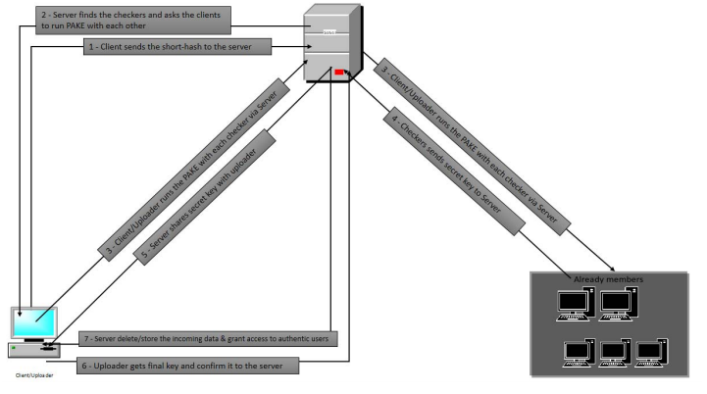

**DATA FLOW DIAGRAM:**

1. The DFD is also called as bubble chart. It is a simple graphical formalism that can be used to represent a system in terms of input data to the system, various processing carried out on this data, and the output data is generated by this system.

2. The data flow diagram (DFD) is one of the most important modeling tools. It is used to model the system components. These components are the system process, the data used by the process, an external entity that interacts with the system and the information flows in the system.

3. DFD shows how the information moves through the system and how it is modified by a series of transformations. It is a graphical technique that depicts information flow and the transformations that are applied as data moves from input to output.

4. DFD is also known as bubble chart. A DFD may be used to represent a system at any level of abstraction. DFD may be partitioned into levels that represent increasing information flow and functional detail

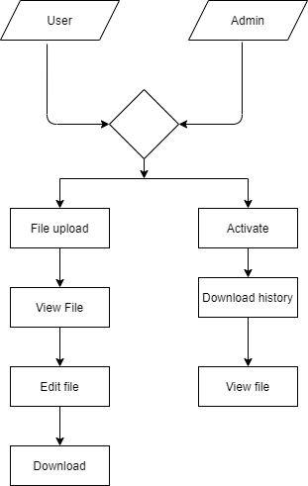

**UML DIAGRAMS:**

UML stands for Unified Modeling Language. UML is a standardized general-purpose modeling language in the field of object-oriented software engineering. The standard is managed, and was created by, the Object Management Group.

The goal is for UML to become a common language for creating models of object oriented computer software. In its current form UML is comprised of two major components: a Meta-model and a notation. In the future, some form of method or process may also be added to; or associated with, UML.

The Unified Modeling Language is a standard language for specifying, Visualization, Constructing and documenting the artifacts of software system, as well as for business modeling and other non-software systems.

The UML represents a collection of best engineering practices that have proven successful in the modeling of large and complex systems.

The UML is a very important part of developing objects oriented software and the software development process. The UML uses mostly graphical notations to express the design of software projects.

**GOALS:**

The Primary goals in the design of the UML are as follows:

1. Provide users a ready-to-use, expressive visual modeling Language so that they can develop and exchange meaningful models.

2. Provide extendibility and specialization mechanisms to extend the core concepts.

3. Be independent of particular programming languages and development process.

4. Provide a formal basis for understanding the modeling language.

5. Encourage the growth of OO tools market.

6. Support higher level development concepts such as collaborations, frameworks, patterns and components.

7. Integrate best practices.

**USE CASE DIAGRAM:**

A use case diagram in the Unified Modeling Language (UML) is a type of behavioral diagram defined by and created from a Use-case analysis. Its purpose is to present a graphical overview of the functionality provided by a system in terms of actors, their goals (represented as use cases), and any dependencies between those use cases. The main purpose of a use case diagram is to show what system functions are performed for which actor. Roles of the actors in the system can be depicted.





**CLASS DIAGRAM:**

In software engineering, a class diagram in the Unified Modeling Language (UML) is a type of static structure diagram that describes the structure of a system by showing the system's classes, their attributes, operations (or methods), and the relationships among the classes. It explains which class contains information



**SEQUENCE DIAGRAM:**

A sequence diagram in Unified Modeling Language (UML) is a kind of interaction diagram that shows how processes operate with one another and in what order. It is a construct of a Message Sequence Chart. Sequence diagrams are sometimes called event diagrams, event scenarios, and timing diagrams.



**ACTIVITY DIAGRAM:**

Activity diagrams are graphical representations of workflows of stepwise activities and actions with support for choice, iteration and concurrency. In the Unified Modeling Language, activity diagrams can be used to describe the business and operational step-by-step workflows of components in a system. An activity diagram shows the overall flow of control



# CHAPTER – 7

## SOFTWARE ENVIRONMENT

## Java Technology

Java technology is both a programming language and a platform.

### The Java Programming Language

### The Java programming language is a high-level language that can be characterized by all of the following buzzwords:

* + - Simple
    - Architecture neutral
    - Object oriented
    - Portable
    - Distributed
    - High performance
    - Interpreted
    - Multithreaded
    - Robust
    - Dynamic
    - Secure

With most programming languages, you either compile or interpret a program so that you can run it on your computer. The Java programming language is unusual in that a program is both compiled and interpreted. With the compiler, first you translate a program into an intermediate language called Java byte codes —the platform-independent codes interpreted by the interpreter on the Java platform. The interpreter parses and runs each Java byte code instruction on the computer. Compilation happens just once; interpretation occurs each time the program is executed. The following figure illustrates how this works.

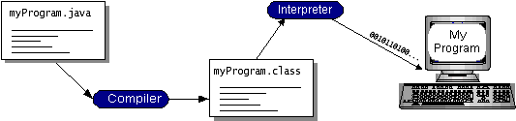

You can think of Java byte codes as the machine code instructions for the Java Virtual Machine (Java VM). Every Java interpreter, whether it’s a development tool or a Web browser that can run applets, is an implementation of the Java VM. Java byte codes help make “write once, run anywhere” possible. You can compile your program into byte codes on any platform that has a Java compiler. The byte codes can then be run on any implementation of the Java VM. That means that as long as a computer has a Java VM, the same program written in the Java programming language can run on Windows 2000, a Solaris workstation, or on an iMac.

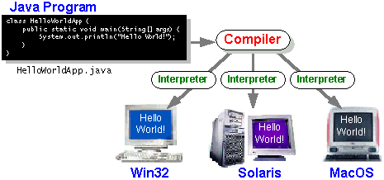

### The Java Platform

A platform is the hardware or software environment in which a program runs. We’ve already mentioned some of the most popular platforms like Windows 2000, Linux, Solaris, and MacOS. Most platforms can be described as a combination of the operating system and hardware. The Java platform differs from most other platforms in that it’s a software-only platform that runs on top of other hardware-based platforms.

The Java platform has two components:

* The Java Virtual Machine (Java VM)
* The Java Application Programming Interface (Java API)

You’ve already been introduced to the Java VM. It’s the base for the Java platform and is ported onto various hardware-based platforms.

The Java API is a large collection of ready-made software components that provide many useful capabilities, such as graphical user interface (GUI) widgets. The Java API is grouped into libraries of related classes and interfaces; these libraries are known as packages. The next section, What Can Java Technology Do? Highlights what functionality some of the packages in the Java API provide.

The following figure depicts a program that’s running on the Java platform. As the figure shows, the Java API and the virtual machine insulate the program from the hardware.

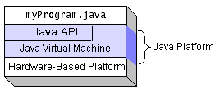

Native code is code that after you compile it, the compiled code runs on a specific hardware platform. As a platform-independent environment, the Java platform can be a bit slower than native code. However, smart compilers, well-tuned interpreters, and just-in-time byte code compilers can bring performance close to that of native code without threatening portability.

## What Can Java Technology Do?

The most common types of programs written in the Java programming language are applets and applications. If you’ve surfed the Web, you’re probably already familiar with applets. An applet is a program that adheres to certain conventions that allow it to run within a Java-enabled browser.

However, the Java programming language is not just for writing cute, entertaining applets for the Web. The general-purpose, high-level Java programming language is also a powerful software platform. Using the generous API, you can write many types of programs.

An application is a standalone program that runs directly on the Java platform. A special kind of application known as a server serves and supports clients on a network. Examples of servers are Web servers, proxy servers, mail servers, and print servers. Another specialized program is a servlet. A servlet can almost be thought of as an applet that runs on the server side. Java Servlets are a popular choice for building interactive web applications, replacing the use of CGI scripts. Servlets are similar to applets in that they are runtime extensions of applications. Instead of working in browsers, though, servlets run within Java Web servers, configuring or tailoring the server.

How does the API support all these kinds of programs? It does so with packages of software components that provides a wide range of functionality. Every full implementation of the Java platform gives you the following features:

* **The essentials**: Objects, strings, threads, numbers, input and output, data structures, system properties, date and time, and so on.
* **Applets**: The set of conventions used by applets.
* **Networking**: URLs, TCP (Transmission Control Protocol), UDP (User Data gram Protocol) sockets, and IP (Internet Protocol) addresses.
* **Internationalization**: Help for writing programs that can be localized for users worldwide. Programs can automatically adapt to specific locales and be displayed in the appropriate language.
* **Security**: Both low level and high level, including electronic signatures, public and private key management, access control, and certificates.
* **Software components**: Known as JavaBeansTM, can plug into existing component architectures.
* **Object serialization**: Allows lightweight persistence and communication via Remote Method Invocation (RMI).
* **Java Database Connectivity (JDBCTM)**: Provides uniform access to a wide range of relational databases.

The Java platform also has APIs for 2D and 3D graphics, accessibility, servers, collaboration, telephony, speech, animation, and more. The following figure depicts what is included in the Java 2 SDK.

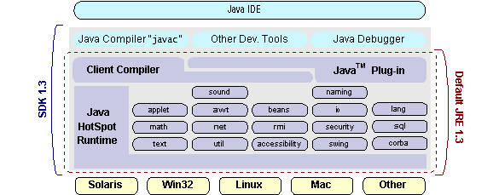

## How Will Java Technology Change My Life?

We can’t promise you fame, fortune, or even a job if you learn the Java programming language. Still, it is likely to make your programs better and requires less effort than other languages. We believe that Java technology will help you do the following:

* **Get started quickly**: Although the Java programming language is a powerful object-oriented language, it’s easy to learn, especially for programmers already familiar with C or C++.
* **Write less code**: Comparisons of program metrics (class counts, method counts, and so on) suggest that a program written in the Java programming language can be four times smaller than the same program in C++.
* **Write better code**: The Java programming language encourages good coding practices, and its garbage collection helps you avoid memory leaks. Its object orientation, its JavaBeans component architecture, and its wide-ranging, easily extendible API let you reuse other people’s tested code and introduce fewer bugs.
* **Develop programs more quickly**: Your development time may be as much as twice as fast versus writing the same program in C++. Why? You write fewer lines of code and it is a simpler programming language than C++.
* **Avoid platform dependencies with 100% Pure Java**: You can keep your program portable by avoiding the use of libraries written in other languages.
* The 100% Pure JavaTM Product Certification Program has a repository of historical process manuals, white papers, brochures, and similar materials online.
* **Write once, run anywhere**: Because 100% Pure Java programs are compiled into machine-independent byte codes, they run consistently on any Java platform.
* **Distribute software more easily**: You can upgrade applets easily from a central server. Applets take advantage of the feature of allowing new classes to be loaded “on the fly,” without recompiling the entire program.

### ODBC

Microsoft Open Database Connectivity (ODBC) is a standard programming interface for application developers and database systems providers. Before ODBC became a *de facto* standard for Windows programs to interface with database systems, programmers had to use proprietary languages for each database they wanted to connect to. Now, ODBC has made the choice of the database system almost irrelevant from a coding perspective, which is as it should be. Application developers have much more important things to worry about than the syntax that is needed to port their program from one database to another when business needs suddenly change.

Through the ODBC Administrator in Control Panel, you can specify the particular database that is associated with a data source that an ODBC application program is written to use. Think of an ODBC data source as a door with a name on it. Each door will lead you to a particular database. For example, the data source named Sales Figures might be a SQL Server database, whereas the Accounts Payable data source could refer to an Access database. The physical database referred to by a data source can reside anywhere on the LAN.

The ODBC system files are not installed on your system by Windows 95. Rather, they are installed when you setup a separate database application, such as SQL Server Client or Visual Basic 4.0. When the ODBC icon is installed in Control Panel, it uses a file called ODBCINST.DLL. It is also possible to administer your ODBC data sources through a stand-alone program called ODBCADM.EXE. There is a 16-bit and a 32-bit version of this program and each maintains a separate list of ODBC data sources.

From a programming perspective, the beauty of ODBC is that the application can be written to use the same set of function calls to interface with any data source, regardless of the database vendor. The source code of the application doesn’t change whether it talks to Oracle or SQL Server. We only mention these two as an example. There are ODBC drivers available for several dozen popular database systems. Even Excel spreadsheets and plain text files can be turned into data sources. The operating system uses the Registry information written by ODBC Administrator to determine which low-level ODBC drivers are needed to talk to the data source (such as the interface to Oracle or SQL Server). The loading of the ODBC drivers is transparent to the ODBC application program. In a client/server environment, the ODBC API even handles many of the network issues for the application programmer.

The advantages of this scheme are so numerous that you are probably thinking there must be some catch. The only disadvantage of ODBC is that it isn’t as efficient as talking directly to the native database interface. ODBC has had many detractors make the charge that it is too slow. Microsoft has always claimed that the critical factor in performance is the quality of the driver software that is used. In our humble opinion, this is true. The availability of good ODBC drivers has improved a great deal recently. And anyway, the criticism about performance is somewhat analogous to those who said that compilers would never match the speed of pure assembly language. Maybe not, but the compiler (or ODBC) gives you the opportunity to write cleaner programs, which means you finish sooner. Meanwhile, computers get faster every year.

**JDBC**

In an effort to set an independent database standard API for Java; Sun Microsystems developed Java Database Connectivity, or JDBC. JDBC offers a generic SQL database access mechanism that provides a consistent interface to a variety of RDBMSs. This consistent interface is achieved through the use of “plug-in” database connectivity modules, or *drivers*. If a database vendor wishes to have JDBC support, he or she must provide the driver for each platform that the database and Java run on.

To gain a wider acceptance of JDBC, Sun based JDBC’s framework on ODBC. As you discovered earlier in this chapter, ODBC has widespread support on a variety of platforms. Basing JDBC on ODBC will allow vendors to bring JDBC drivers to market much faster than developing a completely new connectivity solution.

JDBC was announced in March of 1996. It was released for a 90 day public review that ended June 8, 1996. Because of user input, the final JDBC v1.0 specification was released soon after.

The remainder of this section will cover enough information about JDBC for you to know what it is about and how to use it effectively. This is by no means a complete overview of JDBC. That would fill an entire book.

### JDBC Goals

Few software packages are designed without goals in mind. JDBC is one that, because of its many goals, drove the development of the API. These goals, in conjunction with early reviewer feedback, have finalized the JDBC class library into a solid framework for building database applications in Java.

The goals that were set for JDBC are important. They will give you some insight as to why certain classes and functionalities behave the way they do. The eight design goals for JDBC are as follows:

1. ***SQL Level API***

The designers felt that their main goal was to define a SQL interface for Java. Although not the lowest database interface level possible, it is at a low enough level for higher-level tools and APIs to be created. Conversely, it is at a high enough level for application programmers to use it confidently. Attaining this goal allows for future tool vendors to “generate” JDBC code and to hide many of JDBC’s complexities from the end user.

1. ***SQL Conformance***

SQL syntax varies as you move from database vendor to database vendor. In an effort to support a wide variety of vendors, JDBC will allow any query statement to be passed through it to the underlying database driver. This allows the connectivity module to handle non-standard functionality in a manner that is suitable for its users.

1. ***JDBC must be implemental on top of common database interfaces***The JDBC SQL API must “sit” on top of other common SQL level APIs. This goal allows JDBC to use existing ODBC level drivers by the use of a software interface. This interface would translate JDBC calls to ODBC and vice versa.
2. ***Provide a Java interface that is consistent with the rest of the Java system***

Because of Java’s acceptance in the user community thus far, the designers feel that they should not stray from the current design of the core Java system.

1. ***Keep it simple***

This goal probably appears in all software design goal listings. JDBC is no exception. Sun felt that the design of JDBC should be very simple, allowing for only one method of completing a task per mechanism. Allowing duplicate functionality only serves to confuse the users of the API.

1. ***Use strong, static typing wherever possible***

Strong typing allows for more error checking to be done at compile time; also, less error appear at runtime.

1. ***Keep the common cases simple***

Because more often than not, the usual SQL calls used by the programmer are simple SELECT’s, INSERT’s, DELETE’s and UPDATE’s, these queries should be simple to perform with JDBC. However, more complex SQL statements should also be possible.

Java ha two things: a programming language and a platform. Java is a high-level programming language that is all of the following

Simple Architecture-neutral

Object-oriented Portable

Distributed High-performance

Interpreted multithreaded

Robust Dynamic

Secure

Java is also unusual in that each Java program is both compiled and interpreted. With a compile you translate a Java program into an intermediate language called Java byte codes the platform-independent code instruction is passed and run on the computer.

Compilation happens just once; interpretation occurs each time the program is executed. The figure illustrates how this works.

**Java Program**

**Compilers**

**Interpreter**

**My Program**

You can think of Java byte codes as the machine code instructions for the Java Virtual Machine (Java VM). Every Java interpreter, whether it’s a Java development tool or a Web browser that can run Java applets, is an implementation of the Java VM. The Java VM can also be implemented in hardware.

Java byte codes help make “write once, run anywhere” possible. You can compile your Java program into byte codes on my platform that has a Java compiler. The byte codes can then be run any implementation of the Java VM. For example, the same Java program can run Windows NT, Solaris, and Macintosh.

## Networking:

### TCP/IP stack

The TCP/IP stack is shorter than the OSI one:

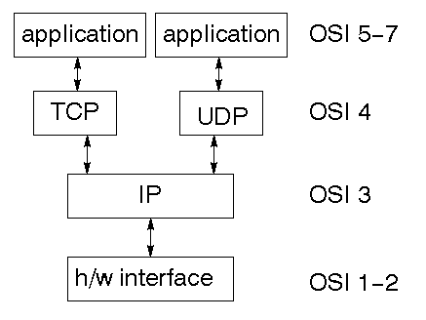

TCP is a connection-oriented protocol; UDP (User Datagram Protocol) is a connectionless protocol.

### IP datagram’s

The IP layer provides a connectionless and unreliable delivery system. It considers each datagram independently of the others. Any association between datagram must be supplied by the higher layers. The IP layer supplies a checksum that includes its own header. The header includes the source and destination addresses. The IP layer handles routing through an Internet. It is also responsible for breaking up large datagram into smaller ones for transmission and reassembling them at the other end.

### UDP

UDP is also connectionless and unreliable. What it adds to IP is a checksum for the contents of the datagram and port numbers. These are used to give a client/server model - see later.

### TCP

TCP supplies logic to give a reliable connection-oriented protocol above IP. It provides a virtual circuit that two processes can use to communicate.

### Internet addresses

In order to use a service, you must be able to find it. The Internet uses an address scheme for machines so that they can be located. The address is a 32 bit integer which gives the IP address. This encodes a network ID and more addressing. The network ID falls into various classes according to the size of the network address.

### Network address

Class A uses 8 bits for the network address with 24 bits left over for other addressing. Class B uses 16 bit network addressing. Class C uses 24 bit network addressing and class D uses all 32.

### Subnet address

Internally, the UNIX network is divided into sub networks. Building 11 is currently on one sub network and uses 10-bit addressing, allowing 1024 different hosts.

### Host address

8 bits are finally used for host addresses within our subnet. This places a limit of 256 machines that can be on the subnet.

### Total address

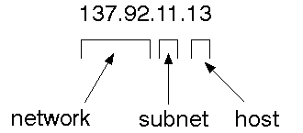

The 32 bit address is usually written as 4 integers separated by dots.

### 

### Port addresses

A service exists on a host, and is identified by its port. This is a 16 bit number. To send a message to a server, you send it to the port for that service of the host that it is running on. This is not location transparency! Certain of these ports are "well known".

### Sockets

A socket is a data structure maintained by the system to handle network connections. A socket is created using the call socket. It returns an integer that is like a file descriptor. In fact, under Windows, this handle can be used with Read File and Write File functions.

#include <sys/types.h>

#include <sys/socket.h>

int socket(int family, int type, int protocol);

Here "family" will be AF_INET for IP communications, protocol will be zero, and type will depend on whether TCP or UDP is used. Two processes wishing to communicate over a network create a socket each. These are similar to two ends of a pipe - but the actual pipe does not yet exist.

**JFree Chart**

JFreeChart is a free 100% Java chart library that makes it easy for developers to display professional quality charts in their applications. JFreeChart's extensive feature set includes:

A consistent and well-documented API, supporting a wide range of chart types;

A flexible design that is easy to extend, and targets both server-side and client-side applications;

Support for many output types, including Swing components, image files (including PNG and JPEG), and vector graphics file formats (including PDF, EPS and SVG);

JFreeChart is "open source" or, more specifically, free software. It is distributed under the terms of the GNU Lesser General Public Licence (LGPL), which permits use in proprietary applications.

## 1. Map Visualizations

Charts showing values that relate to geographical areas. Some examples include: (a) population density in each state of the United States, (b) income per capita for each country in Europe, (c) life expectancy in each country of the world. The tasks in this project include:

Sourcing freely redistributable vector outlines for the countries of the world, states/provinces in particular countries (USA in particular, but also other areas);

Creating an appropriate dataset interface (plus default implementation), a rendered, and integrating this with the existing XYPlot class in JFreeChart;

Testing, documenting, testing some more, documenting some more.

## 2. Time Series Chart Interactivity

Implement a new (to JFreeChart) feature for interactive time series charts --- to display a separate control that shows a small version of ALL the time series data, with a sliding "view" rectangle that allows you to select the subset of the time series data to display in the main chart.

## 3. Dashboards

There is currently a lot of interest in dashboard displays. Create a flexible dashboard mechanism that supports a subset of JFreeChart chart types (dials, pies, thermometers, bars, and lines/time series) that can be delivered easily via both Java Web Start and an applet.

## 4. Property Editors

The property editor mechanism in JFreeChart only handles a small subset of the properties that can be set for charts. Extend (or reimplement) this mechanism to provide greater end-user control over the appearance of the charts.

**What is a Java Web Application?**

A Java web application generates interactive web pages containing various types of markup language (HTML, XML, and so on) and dynamic content. It is typically comprised of web components such as JavaServer Pages (JSP), servlets and JavaBeans to modify and temporarily store data, interact with databases and web services, and render content in response to client requests.

Because many of the tasks involved in web application development can be repetitive or require a surplus of boilerplate code, web frameworks can be applied to alleviate the overhead associated with common activities. For example, many frameworks, such as JavaServer Faces, provide libraries for templating pages and session management, and often promote code reuse.

**What is Java EE?**

Java EE (Enterprise Edition) is a widely used platform containing a set of coordinated technologies that significantly reduce the cost and complexity of developing, deploying, and managing multi-tier, server-centric applications. Java EE builds upon the Java SE platform and provides a set of APIs (application programming interfaces) for developing and running portable, robust, scalable, reliable and secure server-side applications.

Some of the fundamental components of Java EE include:

* Enterprise JavaBeans (EJB): a managed, server-side component architecture used to encapsulate the business logic of an application. EJB technology enables rapid and simplified development of distributed, transactional, secure and portable applications based on Java technology.
* Java Persistence API (JPA): a framework that allows developers to manage data using object-relational mapping (ORM) in applications built on the Java Platform.

**JavaScript and Ajax Development**

JavaScript is an object-oriented scripting language primarily used in client-side interfaces for web applications. Ajax (Asynchronous JavaScript and XML) is a Web 2.0 technique that allows changes to occur in a web page without the need to perform a page refresh. JavaScript toolkits can be leveraged to implement Ajax-enabled components and functionality in web pages.

**Web Server and Client**

Web Server is a software that can process the client request and send the response back to the client. For example, Apache is one of the most widely used web server. Web Server runs on some physical machine and listens to client request on specific port.

A web client is a software that helps in communicating with the server. Some of the most widely used web clients are Firefox, Google Chrome, Safari etc. When we request something from server (through URL), web client takes care of creating a request and sending it to server and then parsing the server response and present it to the user.

**HTML and HTTP**

Web Server and Web Client are two separate softwares, so there should be some common language for communication. HTML is the common language between server and client and stands for **H**yper**T**ext **M**arkup **L**anguage.

Web server and client needs a common communication protocol, HTTP (**H**yper**T**ext **T**ransfer **P**rotocol) is the communication protocol between server and client. HTTP runs on top of TCP/IP communication protocol.

Some of the important parts of HTTP Request are:

* **HTTP Method** – action to be performed, usually GET, POST, PUT etc.
* **URL** – Page to access
* **Form Parameters** – similar to arguments in a java method, for example user,password details from login page.

Sample HTTP Request:

|  |  |
| --- | --- |
| 1  2  3 | GET /FirstServletProject/jsps/hello.jsp HTTP/1.1  Host: localhost:8080  Cache-Control: no-cache |

Some of the important parts of HTTP Response are:

* **Status Code** – an integer to indicate whether the request was success or not. Some of the well known status codes are 200 for success, 404 for Not Found and 403 for Access Forbidden.
* **Content Type** – text, html, image, pdf etc. Also known as MIME type
* **Content** – actual data that is rendered by client and shown to user.

**MIME Type or Content Type**: If you see above sample HTTP response header, it contains tag “Content-Type”. It’s also called MIME type and server sends it to client to let them know the kind of data it’s sending. It helps client in rendering the data for user. Some of the mostly used mime types are text/html, text/xml, application/xml etc.

### 

### Understanding URL

URL is acronym of Universal Resource Locator and it’s used to locate the server and resource. Every resource on the web has it’s own unique address. Let’s see parts of URL with an example.

**http://localhost:8080/FirstServletProject/jsps/hello.jsp**

**http://** – This is the first part of URL and provides the communication protocol to be used in server-client communication.

**localhost** – The unique address of the server, most of the times it’s the hostname of the server that maps to unique IP address. Sometimes multiple hostnames point to same IP addresses and web server virtual host takes care of sending request to the particular server instance.

**8080** – This is the port on which server is listening, it’s optional and if we don’t provide it in URL then request goes to the default port of the protocol. Port numbers 0 to 1023 are reserved ports for well known services, for example 80 for HTTP, 443 for HTTPS, 21 for FTP etc.

**FirstServletProject/jsps/hello.jsp** – Resource requested from server. It can be static html, pdf, JSP, servlets, PHP etc.

### 

### Why we need Servlet and JSPs?

Web servers are good for static contents HTML pages but they don’t know how to generate dynamic content or how to save data into databases, so we need another tool that we can use to generate dynamic content. There are several programming languages for dynamic content like PHP, Python, Ruby on Rails, Java Servlets and JSPs.

Java Servlet and JSPs are server side technologies to extend the capability of web servers by providing support for dynamic response and data persistence.

### 

### Web Container

Tomcat is a web container, when a request is made from Client to web server, it passes the request to web container and it’s web container job to find the correct resource to handle the request (servlet or JSP) and then use the response from the resource to generate the response and provide it to web server. Then web server sends the response back to the client.

When web container gets the request and if it’s for servlet then container creates two Objects HTTPServletRequest and HTTPServletResponse. Then it finds the correct servlet based on the URL and creates a thread for the request. Then it invokes the servlet service() method and based on the HTTP method service() method invokes doGet() or doPost() methods. Servlet methods generate the dynamic page and write it to response. Once servlet thread is complete, container converts the response to HTTP response and send it back to client.

Some of the important work done by web container are:

* **Communication Support** – Container provides easy way of communication between web server and the servlets and JSPs. Because of container, we don’t need to build a server socket to listen for any request from web server, parse the request and generate response. All these important and complex tasks are done by container and all we need to focus is on our business logic for our applications.
* **Lifecycle and Resource Management** – Container takes care of managing the life cycle of servlet. Container takes care of loading the servlets into memory, initializing servlets, invoking servlet methods and destroying them. Container also provides utility like JNDI for resource pooling and management.
* **Multithreading Support** – Container creates new thread for every request to the servlet and when it’s processed the thread dies. So servlets are not initialized for each request and saves time and memory.
* **JSP Support** – JSPs doesn’t look like normal java classes and web container provides support for JSP. Every JSP in the application is compiled by container and converted to Servlet and then container manages them like other servlets.
* **Miscellaneous Task** – Web container manages the resource pool, does memory optimizations, run garbage collector, provides security configurations, support for multiple applications, hot deployment and several other tasks behind the scene that makes our life easier.

### 

### Web Application Directory Structure

Java Web Applications are packaged as Web Archive (WAR) and it has a defined structure. You can export above dynamic web project as WAR file and unzip it to check the hierarchy. It will be something like below image.

[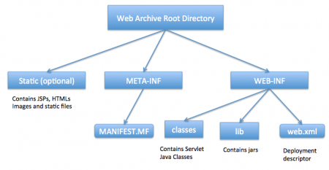](http://www.journaldev.com/wp-content/uploads/2013/08/WAR-directory-structure.png)

### Deployment Descriptor

**web.xml** file is the deployment descriptor of the web application and contains mapping for servlets (prior to 3.0), welcome pages, security configurations, session timeout settings etc.

Thats all for the java web application startup tutorial, we will explore Servlets and JSPs more in future posts.

### MySQL:

MySQL, the most popular Open Source SQL database management system, is developed, distributed, and supported by Oracle Corporation.

The MySQL Web site (http://www.mysql.com/) provides the latest information about MySQL software.

* **MySQL is a database management system.**

A database is a structured collection of data. It may be anything from a simple shopping list to a picture gallery or the vast amounts of information in a corporate network. To add, access, and process data stored in a computer database, you need a database management system such as MySQL Server. Since computers are very good at handling large amounts of data, database management systems play a central role in computing, as standalone utilities, or as parts of other applications.

* **MySQL databases are relational.**

A relational database stores data in separate tables rather than putting all the data in one big storeroom. The database structures are organized into physical files optimized for speed. The logical model, with objects such as databases, tables, views, rows, and columns, offers a flexible programming environment. You set up rules governing the relationships between different data fields, such as one-to-one, one-to-many, unique, required or optional, and “pointers” between different tables. The database enforces these rules, so that with a well-designed database, your application never sees inconsistent, duplicate, orphan, out-of-date, or missing data.

The SQL part of “MySQL” stands for “Structured Query Language”. SQL is the most common standardized language used to access databases. Depending on your programming environment, you might enter SQL directly (for example, to generate reports), embed SQL statements into code written in another language, or use a language-specific API that hides the SQL syntax.

SQL is defined by the ANSI/ISO SQL Standard. The SQL standard has been

evolving since 1986 and several versions exist. In this manual, “SQL-92” refers to the standard released in 1992, “SQL:1999” refers to the standard released in 1999, and “SQL:2003” refers to the current version of the standard. We use the phrase “the SQL standard” to mean the current version of the SQL Standard at any time.

* **MySQL software is Open Source.**

Open Source means that it is possible for anyone to use and modify the software. Anybody can download the MySQL software from the Internet and use it without paying anything. If you wish, you may study the source code and change it to suit your needs. The MySQL software uses the GPL (GNU General Public License), http://www.fsf.org/licenses/, to define what you may and may not do with the software in different situations. If you feel uncomfortable with the GPL or need to embed MySQL code into a commercial application, you can buy a commercially licensed version from us. See the MySQL Licensing Overview for more information (http://www.mysql.com/company/legal/licensing/).

* **The MySQL Database Server is very fast, reliable, scalable, and easy to use.**

If that is what you are looking for, you should give it a try. MySQL Server can run comfortably on a desktop or laptop, alongside your other applications, web servers, and so on, requiring little or no attention. If you dedicate an entire machine to MySQL, you can adjust the settings to take advantage of all the memory, CPU power, and I/O capacity available. MySQL can also scale up to clusters of machines, networked together.

You can find a performance comparison of MySQL Server with other database managers on our benchmark page.

MySQL Server was originally developed to handle large databases much faster than existing solutions and has been successfully used in highly demanding production environments for several years. Although under constant development, MySQL Server today offers a rich and useful set of functions. Its connectivity, speed, and security make MySQL Server highly suited for accessing databases on the Internet.

**MySQL Server works in client/server or embedded systems.**

The MySQL Database Software is a client/server system that consists of a multi-threaded SQL server that supports different backends, several different client programs and libraries, administrative tools, and a wide range of application programming interfaces (APIs).

We also provide MySQL Server as an embedded multi-threaded library that you can link into your application to get a smaller, faster, easier-to-manage standalone product.

* **A large amount of contributed MySQL software is available.**

MySQL Server has a practical set of features developed in close cooperation with our users. It is very likely that your favorite application or language supports the MySQL Database Server.

The official way to pronounce “MySQL” is “My Ess Que Ell” (not “my sequel”), but we do not mind if you pronounce it as “my sequel” or in some other localized way.

## CHAPTER -8

## SOFTWARE INSTALLATION

## MySql:

## What is MySQL?

## [MySQL](https://www.geeksforgeeks.org/what-is-mysql/) is an open-source relational database management system ([RDBMS](https://www.geeksforgeeks.org/rdbms-full-form/)) that uses Structured Query Language ([SQL](https://www.geeksforgeeks.org/sql-tutorial/)) to manage and manipulate databases.

## It is widely used for storing, retrieving, and managing data in applications ranging from small-scale projects to large enterprise systems.

## MySQL is known for its reliability, scalability, and ease of use, making it a popular choice for web developers and organizations worldwide.

**Step 1: Download MySQL Installer**

1.Open your web browser and go to:  
<https://dev.mysql.com/downloads/installer/>

2.Click on "MySQL Server 5.0".

3.Click "Next”

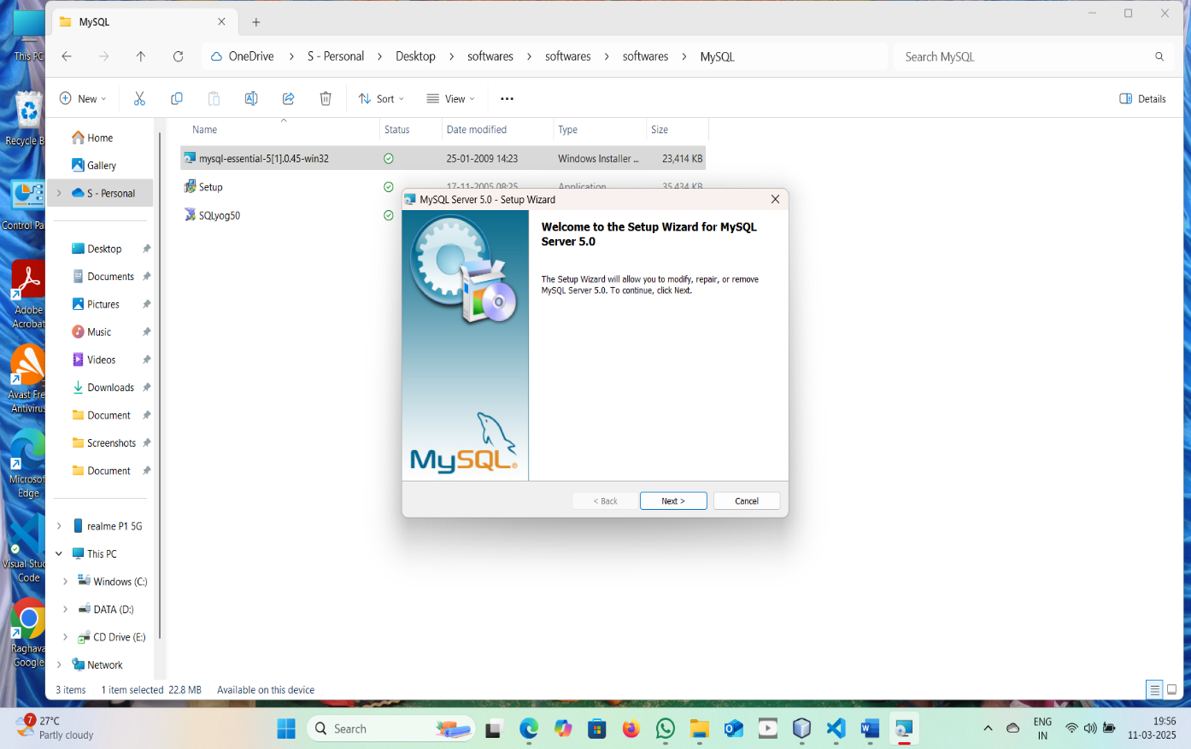

**Step 2: Run the Installer**

1. Locate the downloaded MySQL Installer (.msi) file.
2. Double-click it to launch the installation.

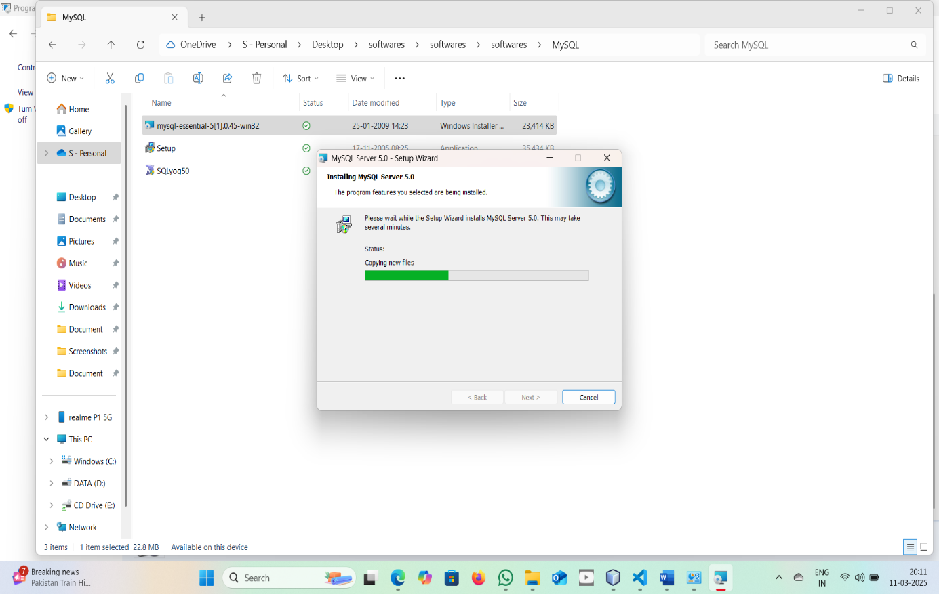

**Step 3: Choose Installation Type**

.

1. Installation Completed Click "Finish".

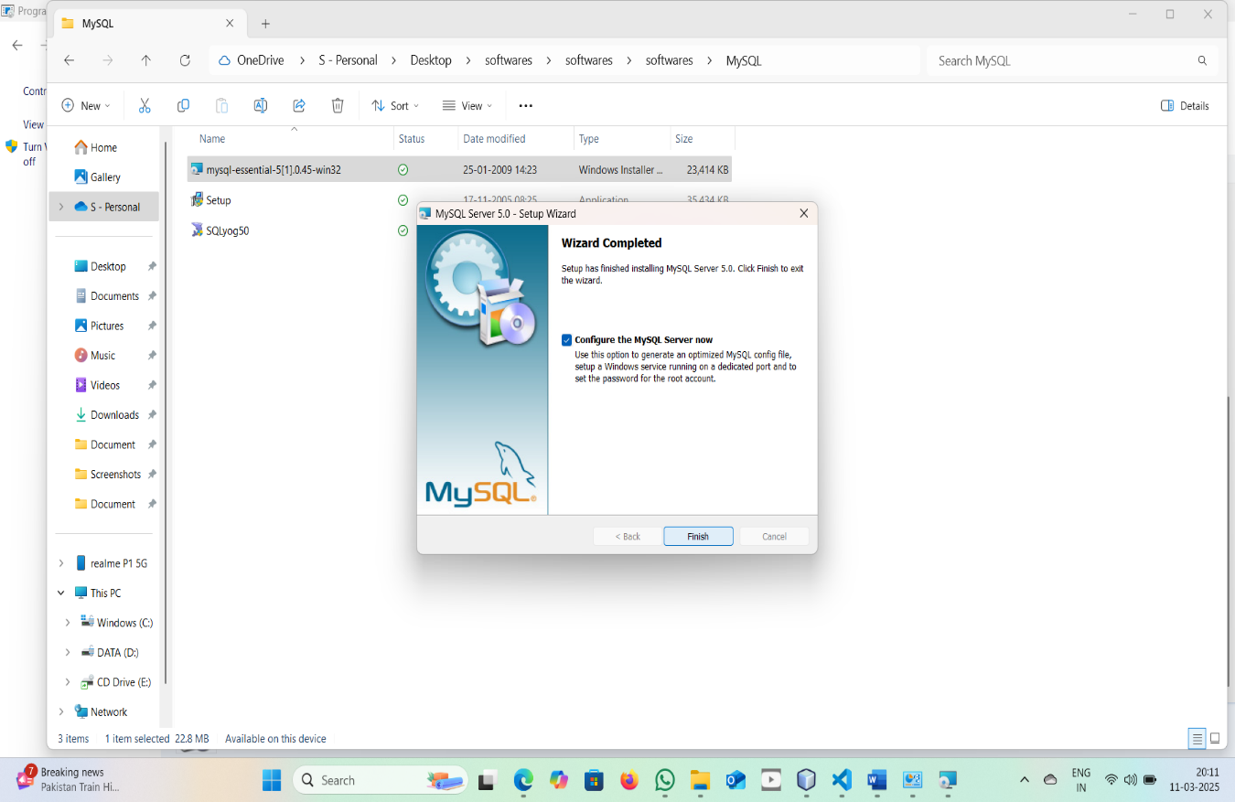

**Step 4: Install Required Components**

1. Welcome to the SQLyog 5.0 setup installation
2. Once all dependencies are installed, click "Next".

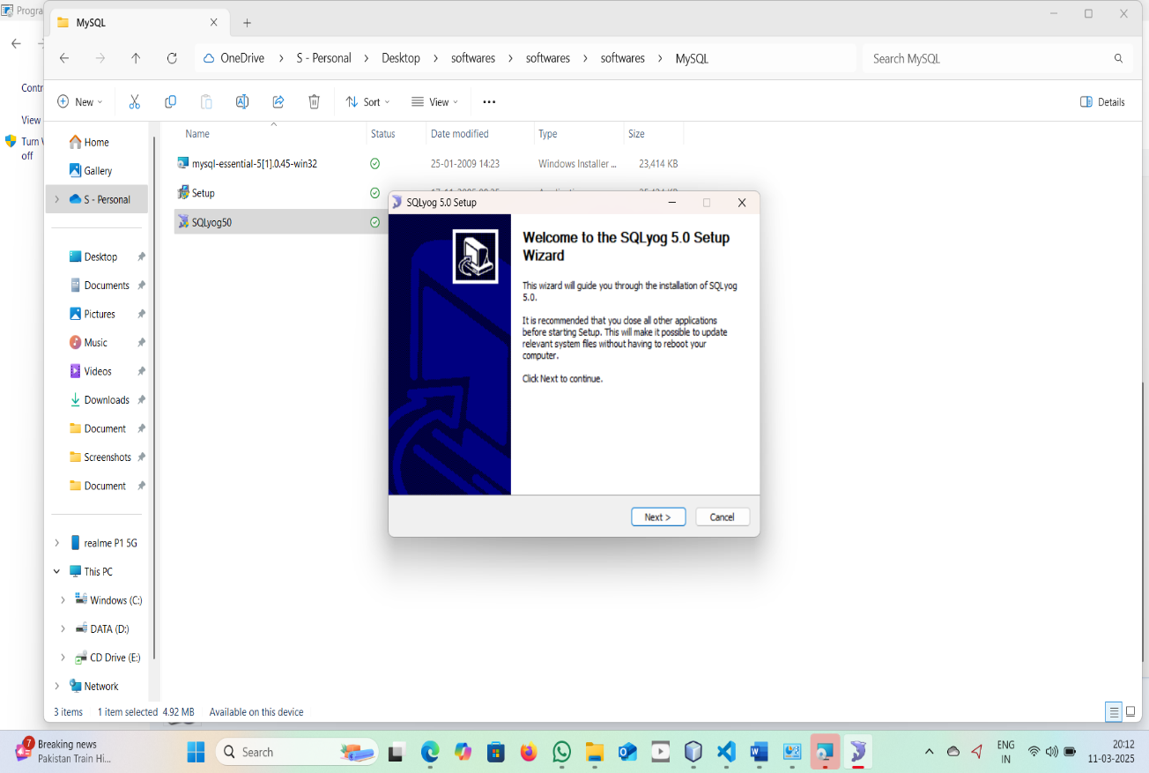

**Step 5: Installing**

1. MySQL as installing (so it starts automatically).
2. Click "Next".

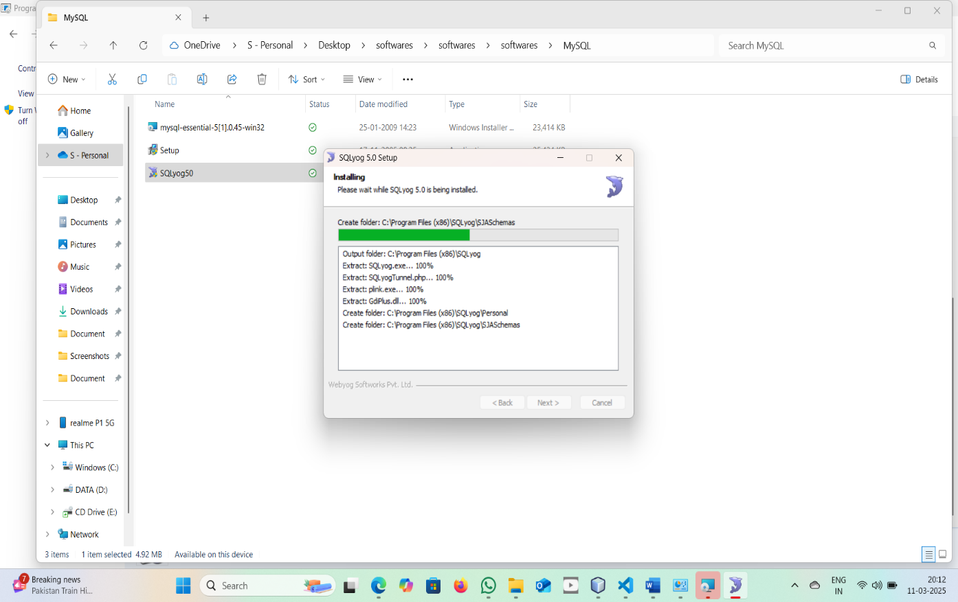

**Step 6: Set MySQL Root Password**

1.SQL Connection Established

2.Enter a strong root password (remember this for future logins).

3.Click "Connect".

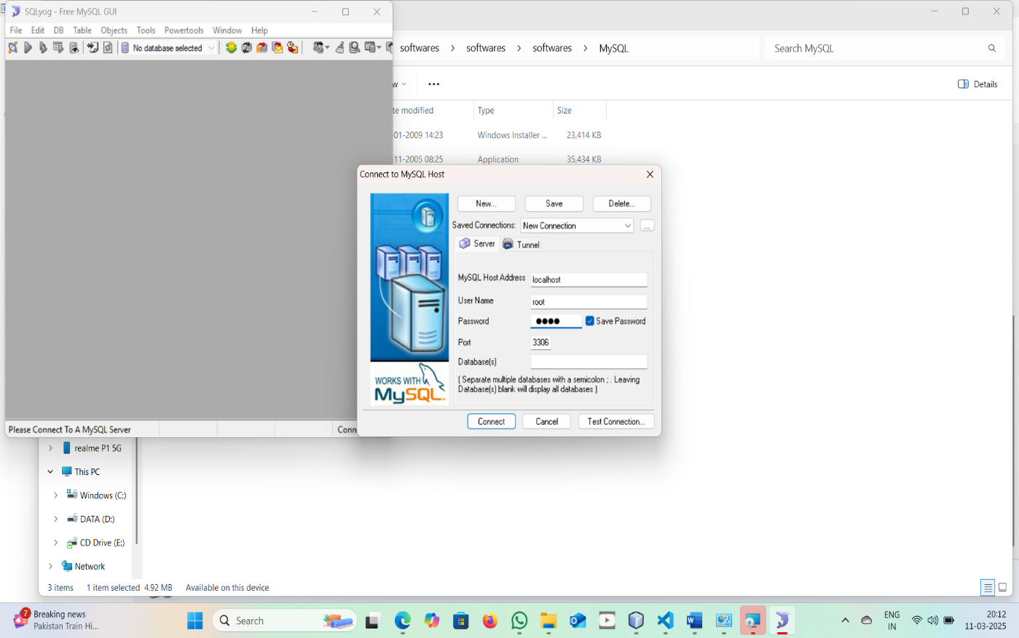

**Step 7: Apply Configuration**

1. Connection is Finish to SQL ".

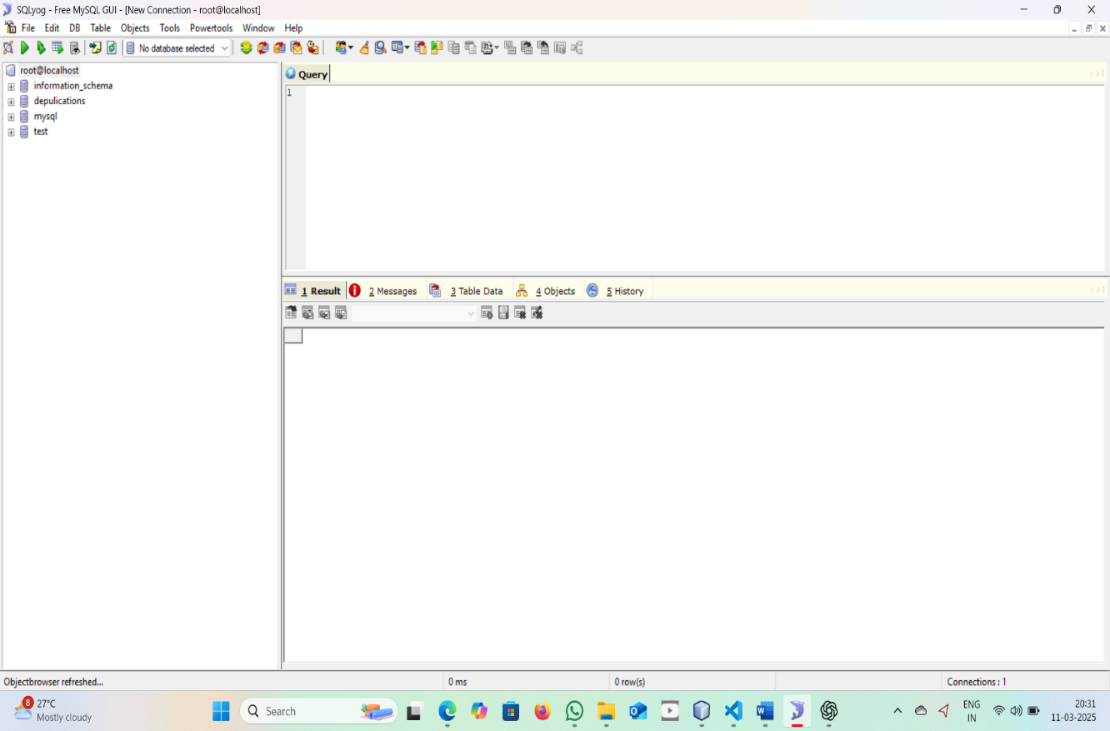

## NetBeans

NetBeans IDE is a Free open-Source, Cross-plate form **Integrated Development Environment (IDE)** with built-in support for the JAVA Programming Language. It can run any machine which consists of the **Java Virtual Machine (JVM).**It consists of many features for application development as follows:

* Drag & Drop**Graphical User Interface (GUI)** Creation.
* Excellent editing (advanced source code editor)
* Web-service
* Excellent debugging
* Wizards, code generation and management tools, and many more.

**Steps of Installation of NetBeans on Windows**

**1.**You need to have a setup file of the NetBeans JAVA into your setup.

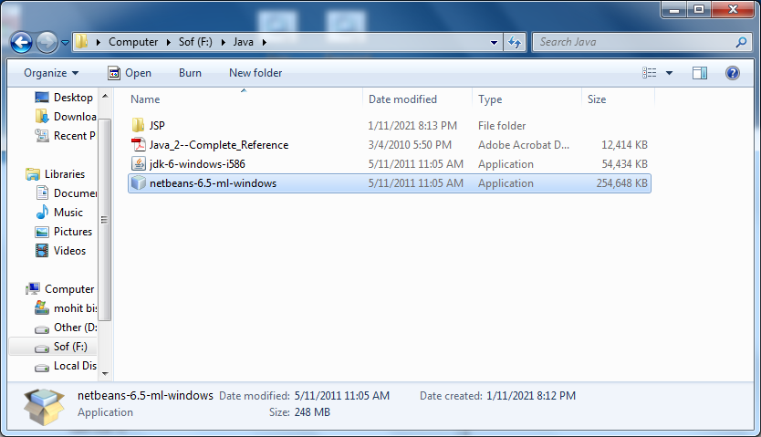

**2.** If you didn’t have the setup you can download from the following link: [https://netbeans.org/images_www/v6/download/community/8.2](https://netbeans.org/images_www/v6/download/community/8.2/)

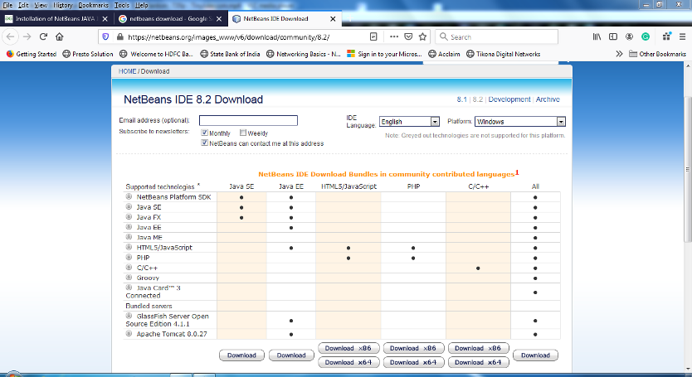

**3.** You can download any type of setup as per your requirements from the above mention web page.  
**4.**  Right-click on the setup or you can Double-Click on the setup by using the mouse.  
**5.** Click on the next option

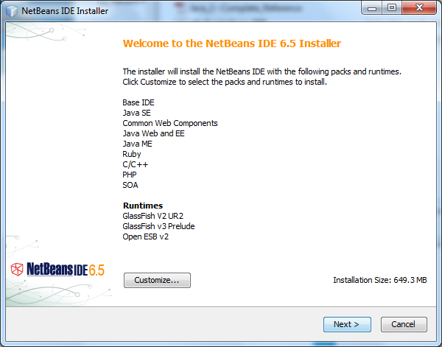

**6.** Check on the “**Private networks,** **such as my home and work network”.**

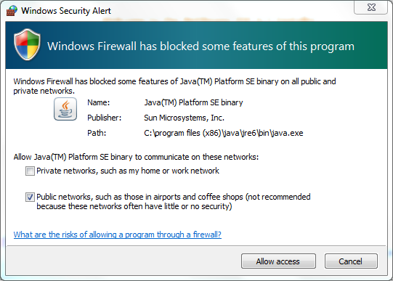

**7.**Click on the **Allow access** button.  
**8.** Check on the**“I accept”** option and click on the “**Next”** button.

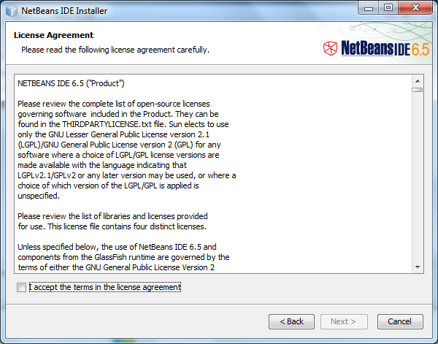

**9.**Select the path where you want to install the software and press the “**Next”** button.

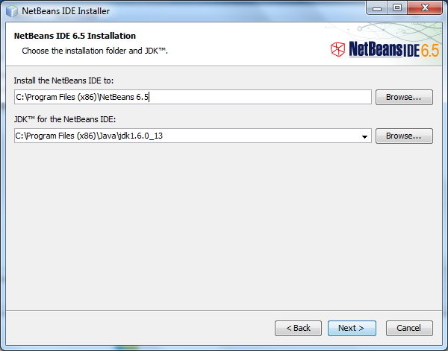

**10.**Set the**Password, User Name & Ports**for the Network Connectivity, or we can use this **UserName and the Password** for the Connecting the Front-End to the Back-End.

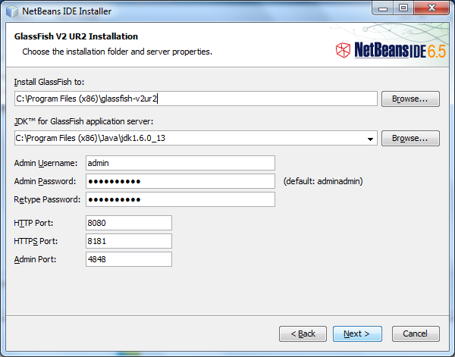

**11.**Click on the “**Next”** button.

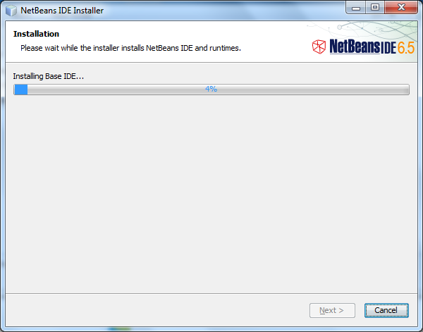

**12.** Click on the “**Install”** button.

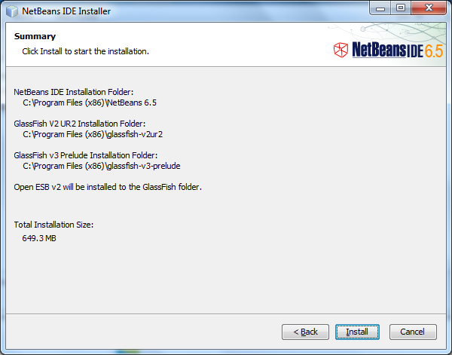

**13.**Wait for the while till the time the setup is properly Installedinto the Computer



**14.** After complication of the setup you can click on the “**Finish”**button or you can also register the Software, for Further Assistance because it is a Free Software.

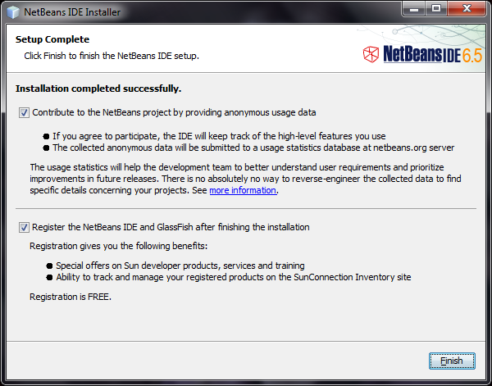

**15.** Now you can start the NetBeans for further use

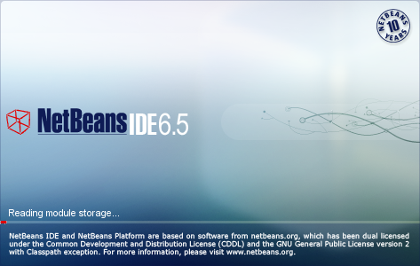

# CHAPTER -9

## SAMPLECODE

## CODE:

## Download1.jsp:

## 

## 

## Userlogin.jsp

## 

## 

## 

## 

## 

## 

## Userreg.jsp

## 

## 

## 

## Viewfile.jsp

## 

## 

## 

## Activateuser.jsp:

## -

## CHAPTER -10

## SYSTEM TEST

The purpose of testing is to discover errors. Testing is the process of trying to discover every conceivable fault or weakness in a work product. It provides a way to check the functionality of components, sub assemblies, assemblies and/or a finished product It is the process of exercising software with the intent of ensuring that the

Software system meets its requirements and user expectations and does not fail in an unacceptable manner. There are various types of test. Each test type addresses a specific testing requirement.

TYPES OF TESTS

Unit testing

Unit testing involves the design of test cases that validate that the internal program logic is functioning properly, and that program inputs produce valid outputs. All decision branches and internal code flow should be validated. It is the testing of individual software units of the application .it is done after the completion of an individual unit before integration. This is a structural testing, that relies on knowledge of its construction and is invasive. Unit tests perform basic tests at component level and test a specific business process, application, and/or system configuration. Unit tests ensure that each unique path of a business process performs accurately to the documented specifications and contains clearly defined inputs and expected results.

***Integration testing***

Integration tests are designed to test integrated software components to determine if they actually run as one program. Testing is event driven and is more concerned with the basic outcome of screens or fields. Integration tests demonstrate that although the components were individually satisfaction, as shown by successfully unit testing, the combination of components is correct and consistent. Integration testing is specifically aimed at exposing the problems that arise from the combination of components.

Functional test

Functional tests provide systematic demonstrations that functions tested are available as specified by the business and technical requirements, system documentation, and user manuals.

Functional testing is centered on the following items:

Valid Input : identified classes of valid input must be accepted.

Invalid Input : identified classes of invalid input must be rejected.

Functions : identified functions must be exercised.

Output : identified classes of application outputs must be exercised.

Systems/Procedures: interfacing systems or procedures must be invoked.

Organization and preparation of functional tests is focused on requirements, key functions, or special test cases. In addition, systematic coverage pertaining to identify Business process flows; data fields, predefined processes, and successive processes must be considered for testing. Before functional testing is complete, additional tests are identified and the effective value of current tests is determined.

System Test

System testing ensures that the entire integrated software system meets requirements. It tests a configuration to ensure known and predictable results. An example of system testing is the configuration oriented system integration test. System testing is based on process descriptions and flows, emphasizing pre-driven process links and integration points.

White Box Testing

White Box Testing is a testing in which in which the software tester has knowledge of the inner workings, structure and language of the software, or at least its purpose. It is purpose. It is used to test areas that cannot be reached from a black box level.

Black Box Testing

Black Box Testing is testing the software without any knowledge of the inner workings, structure or language of the module being tested. Black box tests, as most other kinds of tests, must be written from a definitive source document, such as specification or requirements document, such as specification or requirements document. It is a testing in which the software under test is treated, as a black box .you cannot “see” into it. The test provides inputs and responds to outputs without considering how the software works.

**Unit Testing:**

Unit testing is usually conducted as part of a combined code and unit test phase of the software lifecycle, although it is not uncommon for coding and unit testing to be conducted as two distinct phases.

**Test strategy and approach**

Field testing will be performed manually and functional tests will be written in detail.

**Test objectives**

* All field entries must work properly.
* Pages must be activated from the identified link.
* The entry screen, messages and responses must not be delayed.

**Features to be tested**

* Verify that the entries are of the correct format
* No duplicate entries should be allowed
* All links should take the user to the correct page.

**Integration Testing:**

Software integration testing is the incremental integration testing of two or more integrated software components on a single platform to produce failures caused by interface defects.

The task of the integration test is to check that components or software applications, e.g. components in a software system or – one step up – software applications at the company level – interact without error.

**Test Results:** All the test cases mentioned above passed successfully. No defects encountered.

**Acceptance Testing:**

User Acceptance Testing is a critical phase of any project and requires significant participation by the end user. It also ensures that the system meets the functional requirements.

**Test Results:** All the test cases mentioned above passed successfully. No defects encountered.

## CHAPTER -11

## Test cases:

|  |  |  |  |  |
| --- | --- | --- | --- | --- |
| S.no | Test Case | Excepted Result | Result | Remarks(IF Fails) |
| 1. | Admin login | If username and password is correct then it will getting valid page. | Pass | If username or password is not correct. |
| 2. | User Registration | If data user is registered successfully. | Pass | If data user is not registered. |
| 4. | User login | Username and password is correct then getting valid page. | Pass | If username or password is wrong. |
| 5. | File upload | Choose or select file and preprocess the file . | Pass | If user is not select file . |
| 6. | File details | User upload file details are available here(we can view the file details) | Pass | If user file is not upload file. |
| 7. | Download | User enter the mac key and then only download the file | Pass | User not enter the key |
| 8. | Download history | View User downlaod history | Pass | If user not download the files |

## CHAPTER -12

**1.Implementation Process:**

The Secure Block-Level Data Deduplication project follows a structured approach that involves:

1. Setting up the development environment
2. Implementing core deduplication functions
3. Building a user-friendly interface
4. Testing and evaluating deduplication efficiency
5. Deploying and optimizing the system

**2. Implementation Steps:**

Step 1: Setup the Development Environment

* Install Python 3.0 (or latest) as the primary programming language.
* Install necessary libraries:
* pip install PyPDF2 scipy numpy scikit-learn flask
* Configure VMware Workstation with Lubuntu 18.04 LTS or use a Linux-based system for testing.

Step 2: Build the Deduplication System

A. Implementing Deduplication Algorithm

1. File-Level Deduplication
   * Generate a hash value for each file using SHA-1.
   * Store hash values in a database (e.g., MySQL or MongoDB).
   * Before saving a new file, check if the hash already exists.
   * If a duplicate is found, return a pointer instead of saving the file again.
2. Block-Level Deduplication
   * Divide files into smaller chunks (e.g., 4 KB blocks).
   * Generate a hash value for each chunk.
   * Check the database for existing hash values.
   * Store only unique chunks and map redundant ones to existing blocks.

Code Example (SHA-1 hashing for deduplication):

import hashlib

def calculate_sha1(file_path):

hasher = hashlib.sha1()

with open(file_path, 'rb') as f:

while chunk := f.read(4096): # Read file in chunks

hasher.update(chunk)

return hasher.hexdigest() # Return SHA-1 hash

B. Implementing Secure Authentication

* Use Password Authentication Key Exchange (PAKE) for secure login.
* Implement Rate Limiting to prevent brute-force attacks.
* Encrypt file contents using AES or RSA encryption before uploading.

Step 3:

Develop the User Interface

Your screenshots document suggests a web-based UI with these modules:

1. Homepage
2. User Registration/Login
3. File Upload & Management
4. Admin Dashboard
5. Download & History Tracking

To build the UI:

* Use Flask (Python) for the backend.
* Use HTML, CSS, and JavaScript for the frontend.
* Implement API endpoints to handle file uploads, deduplication, and downloads.

Example Flask API for File Upload:

from flask import Flask, request

import os

app = Flask(__name__)

UPLOAD_FOLDER = 'uploads/'

os.makedirs(UPLOAD_FOLDER, exist_ok=True)

@app.route('/upload', methods=['POST'])

def upload_file():

file = request.files['file']

file_path = os.path.join(UPLOAD_FOLDER, file.filename)

file.save(file_path)

return {"message": "File uploaded successfully"}, 200

if __name__ == '__main__':

app.run(debug=True)

Step 4:

Testing & Performance Evaluation

* Test deduplication efficiency using a 267 MB dataset.
* Compare File-Level vs Block-Level deduplication:
  + File-Level: 10.5% storage reduction
  + Block-Level: 15.21% storage reduction
* Optimize performance by adjusting chunk size & hash function.

1. **Implementation procedure:**

1. Run the Server

python app.py

2. Open the Web Interface

* Go to http://localhost:5000
* Register/Login as a user or admin.

3. Upload Files

* Click Upload File to add files.
* System checks for duplicates and saves unique data.

4. Manage Files

* View, edit, and download files from User Dashboard.

5. Admin Functions

* View all uploaded files.
* Activate/deactivate users.
* Monitor download history.

## CHAPTER -13

**Screenshots**

**Homepage:**

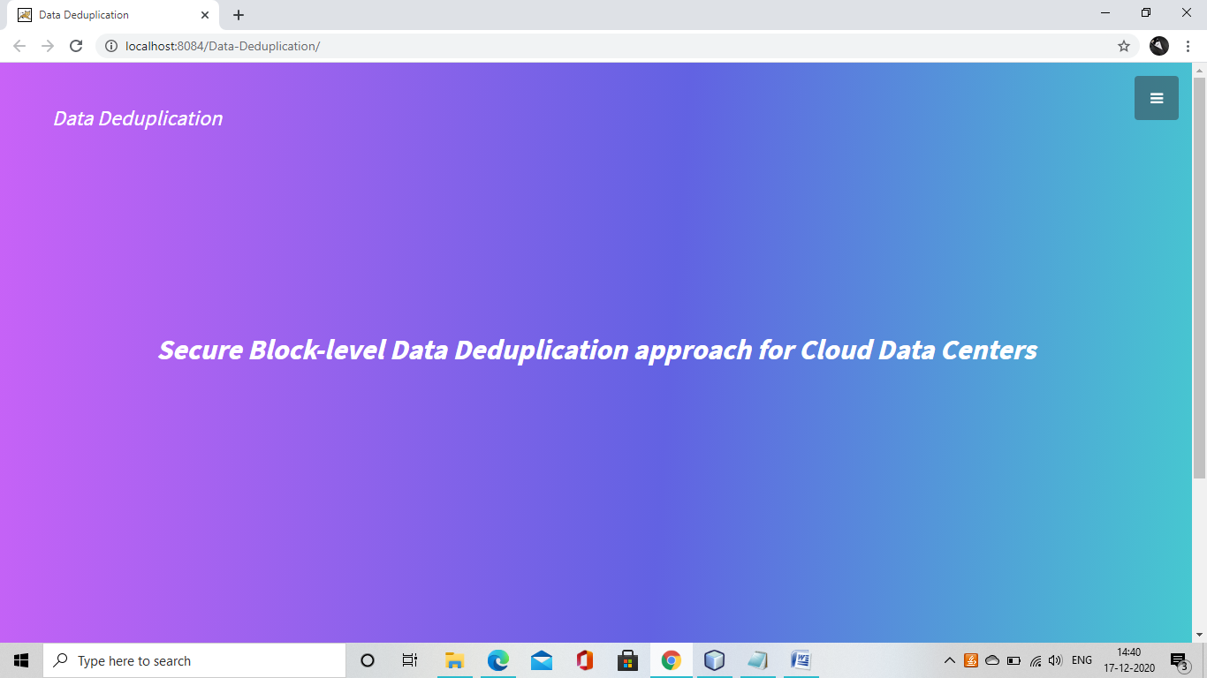

**User Registration:**

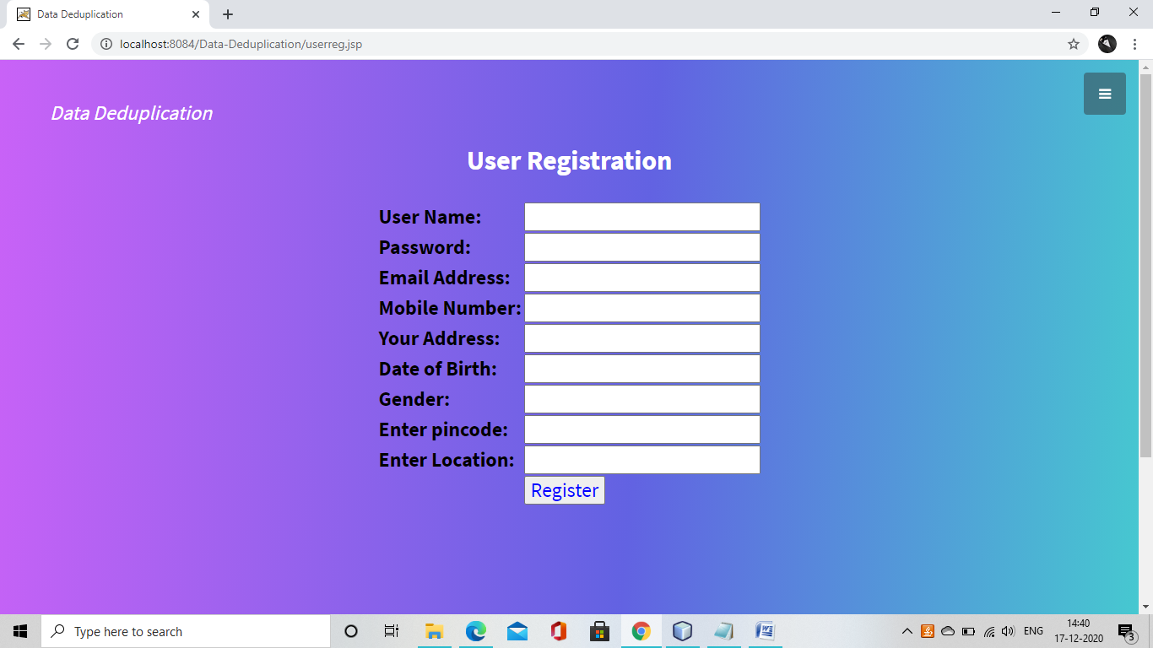

**User login:**

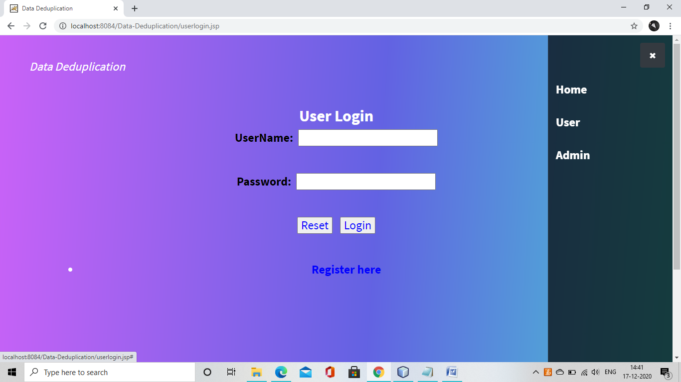

**Admin:**

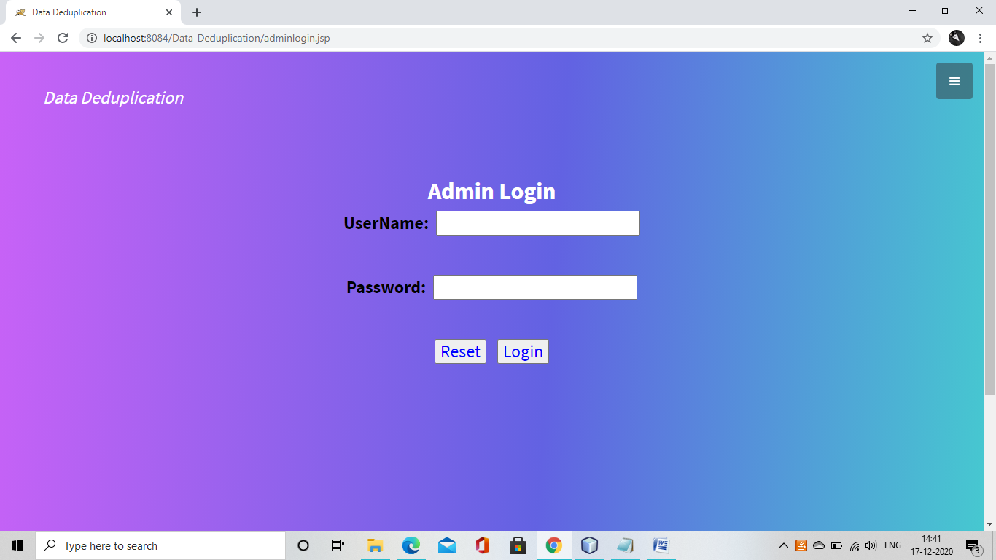

**User home:**

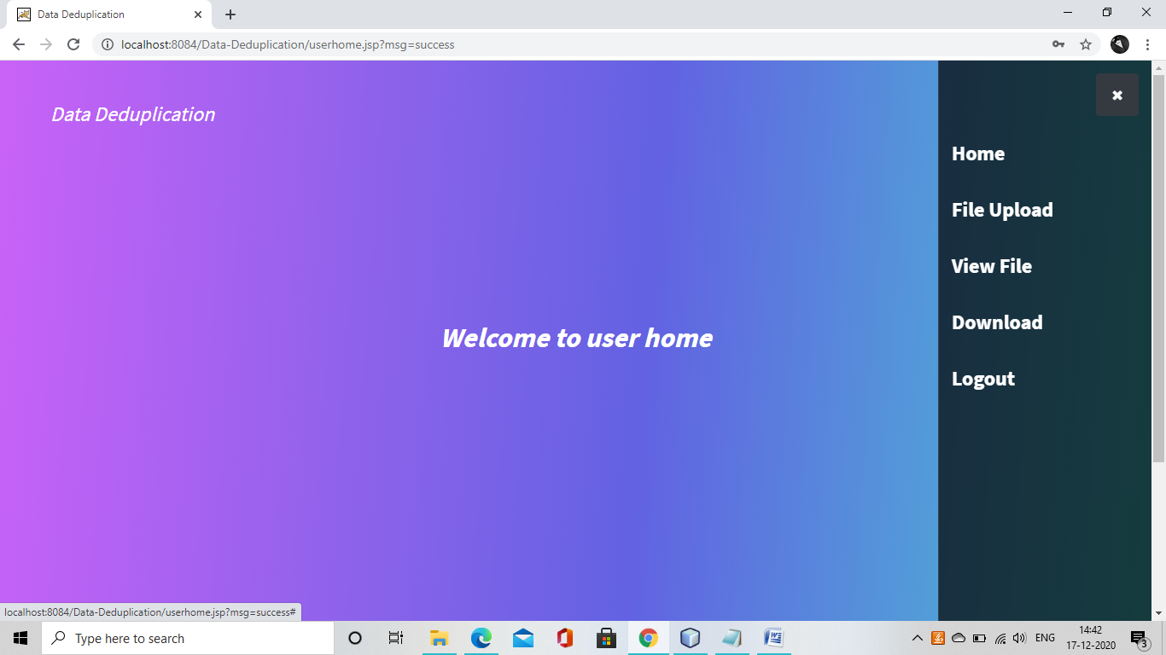

**File Upload:**

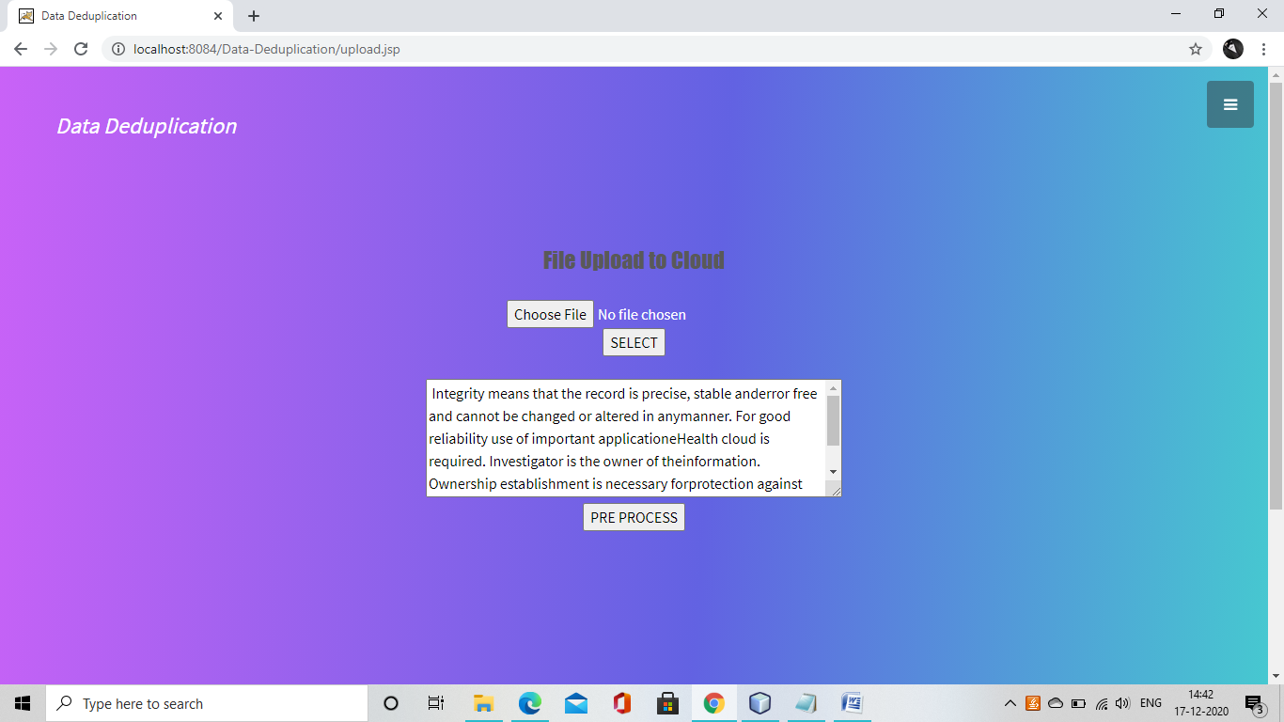

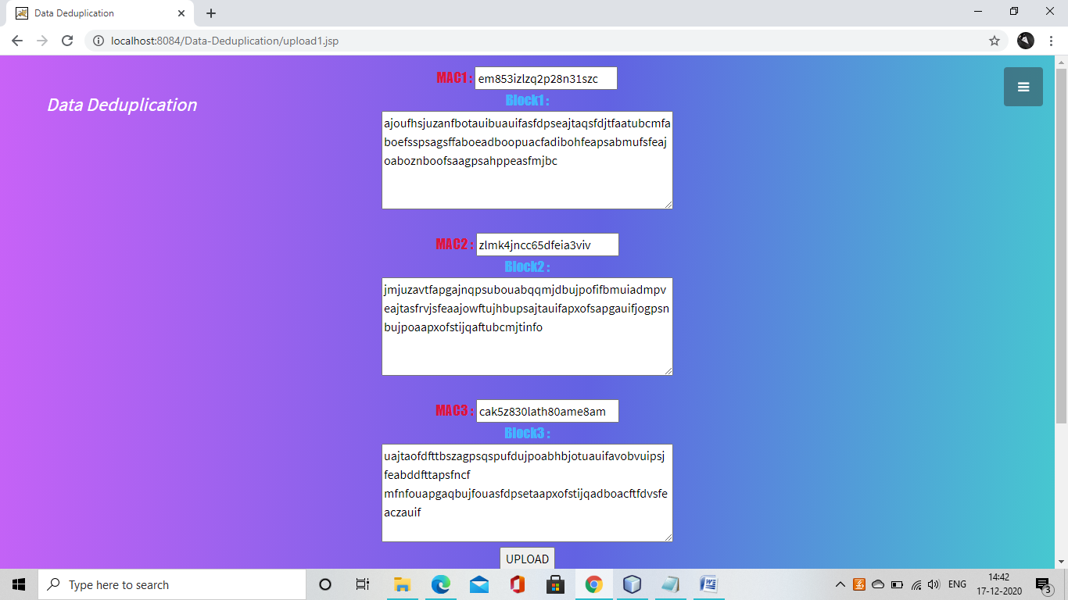

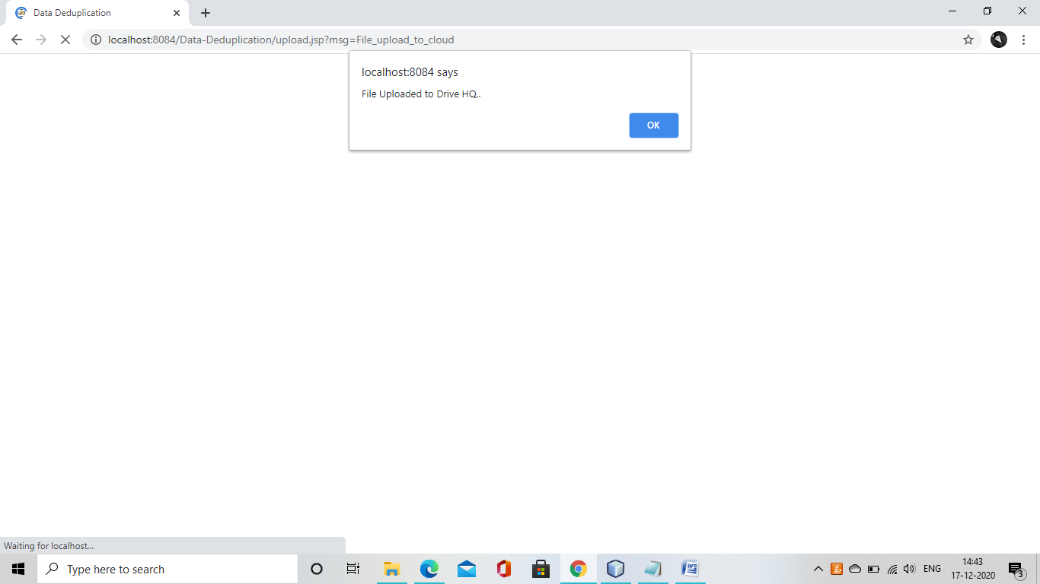

**View file:;**

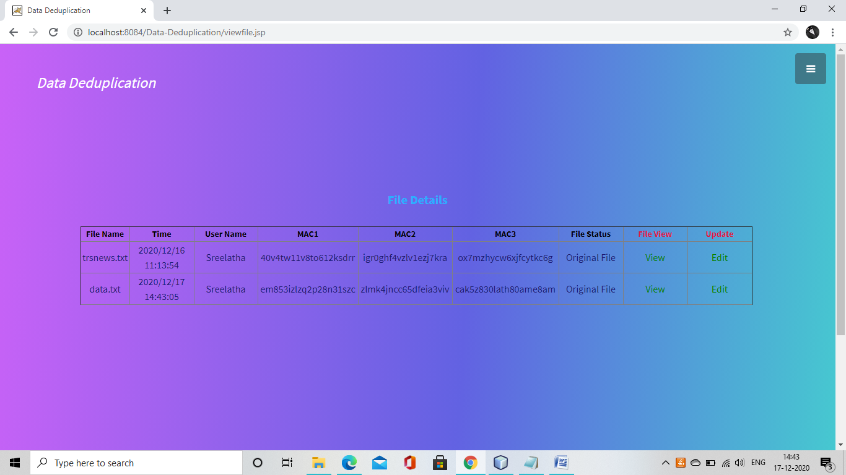

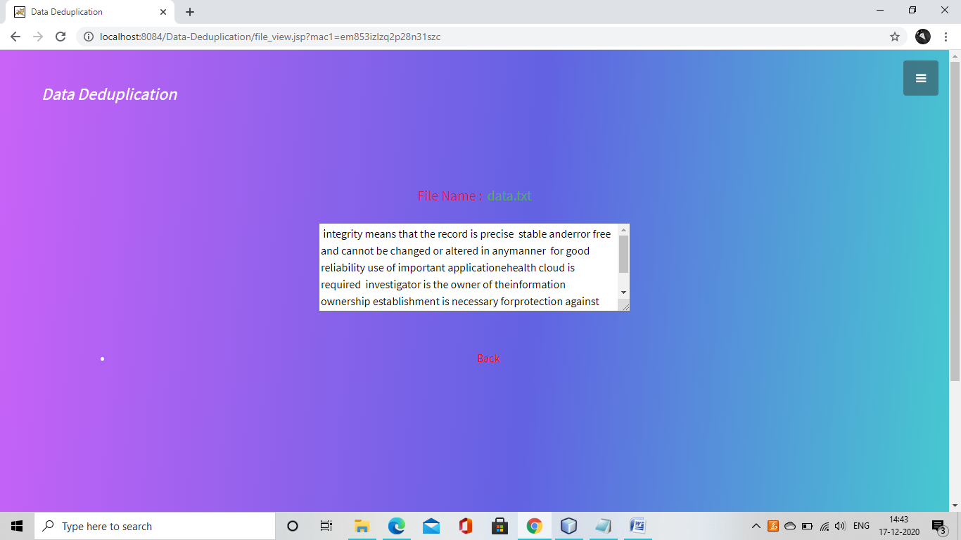

**Edit file:**

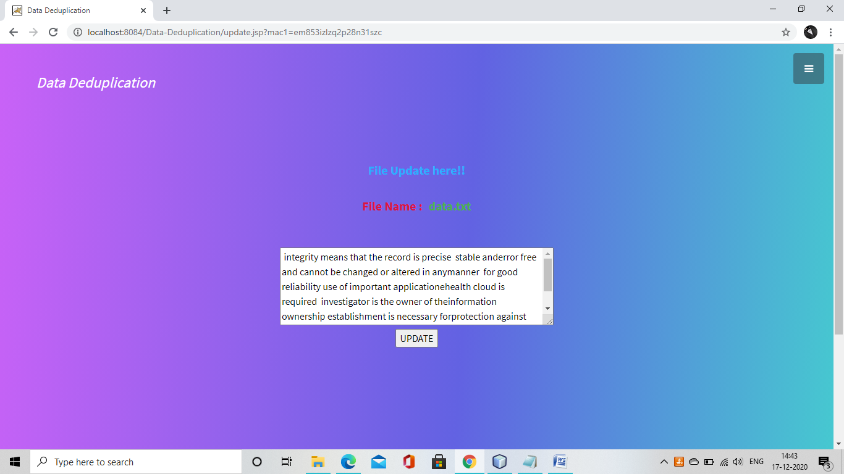

**Download :**

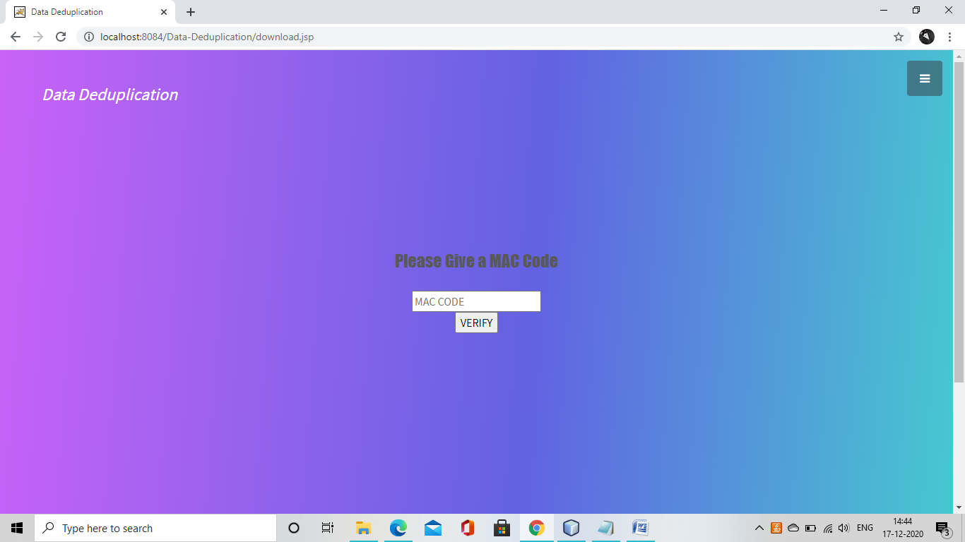

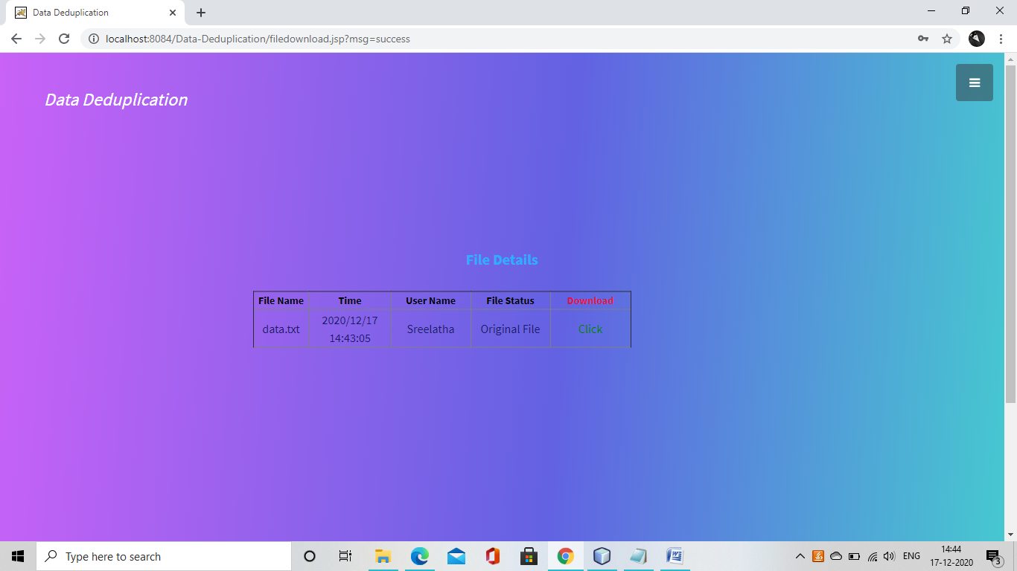

**Admin home:**

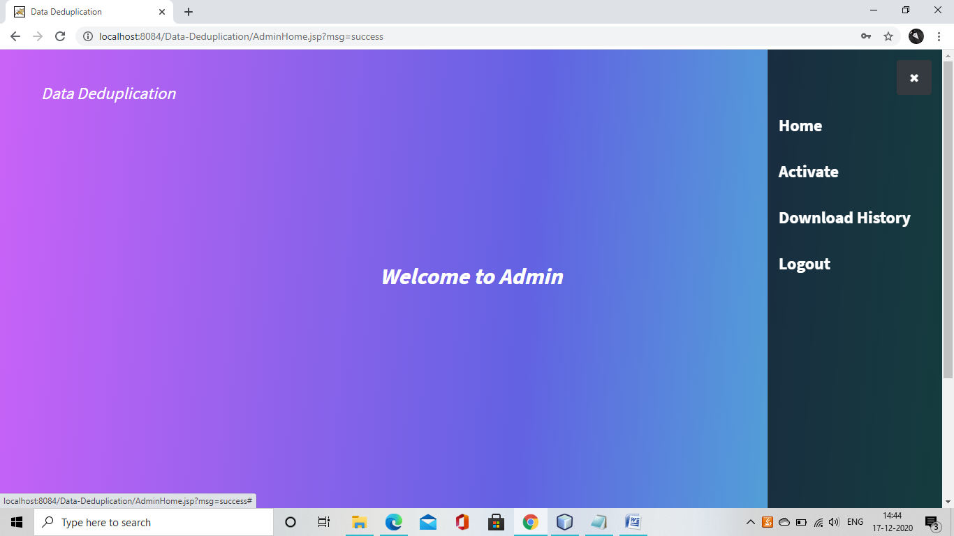

**Activate:**

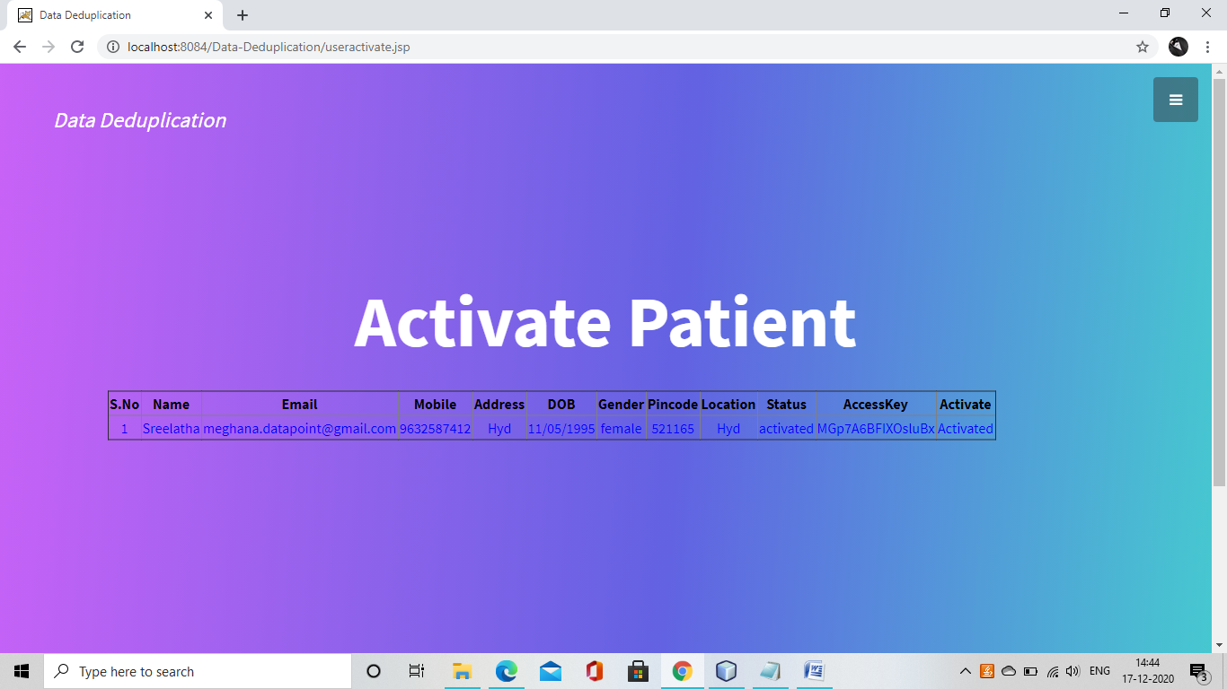

**Download History:**

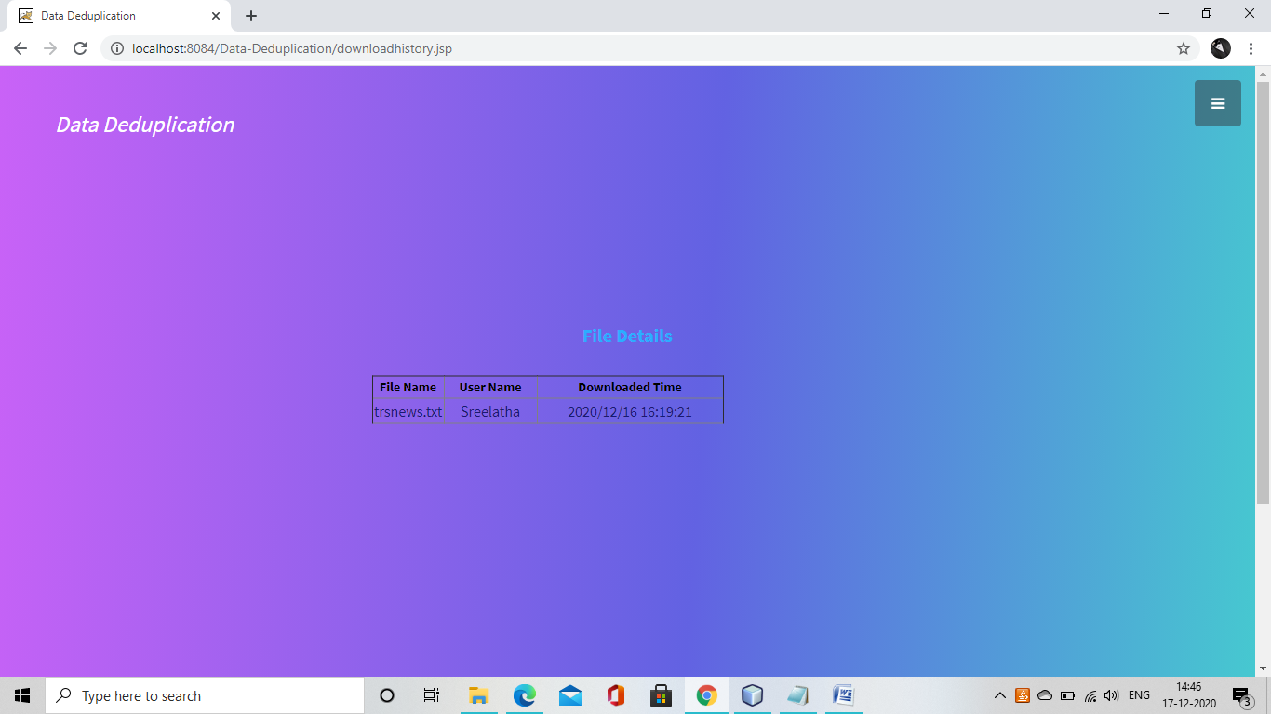

# CHAPTER -14

**Conclusion:**

The Secure Block-Level Data Deduplication System significantly improves cloud storage efficiency by eliminating redundant data at a block level rather than a file level. This method ensures:

✔ Optimized Storage – Achieves up to 15.21% reduction in storage space compared to traditional file-level deduplication.  
✔ Improved Security – Uses encryption, PAKE authentication, and rate limiting to prevent unauthorized access and brute-force attacks.  
✔ Bandwidth Optimization – Reduces redundant file transfers, making cloud storage more efficient.  
✔ User-Friendly Interface – Allows users to upload, manage, and download files securely through a web-based UI.

Overall, this project demonstrates an effective way to minimize cloud storage costs, enhance data security, and improve server performance.

**Future Enhancements:**

To further improve this project, the following enhancements can be implemented:

🔹 Real-Time Deduplication – Implement background deduplication to optimize storage without user intervention.  
🔹 Machine Learning Optimization – Use AI algorithms to predict and classify duplicate files more efficiently.  
🔹 Distributed Deduplication – Extend deduplication across multiple cloud servers for better scalability.  
🔹 Blockchain Integration – Use blockchain to enhance data integrity and prevent unauthorized data modifications.  
🔹 Data Compression – Implement compression algorithms alongside deduplication to further reduce storage needs.  
🔹 Mobile & Cross-Platform Support – Develop Android/iOS apps to provide seamless access to the deduplication system.

By implementing these improvements, the system can become more secure, scalable, and efficient for real-world cloud storage applications.

# CHAPTER-15

**REFERENCES:**

[1] Gantz, John, and David Reinsel. "The digital universe in 2020: Big data, bigger digital shadows, and biggest growth in the far east." IDC iView: IDC Analyze the future 2007.2012 (2012): 1-16.

[2] Dropbox hacked." http://www.businessinsider.com/dropbox-hacked2014-10. Accessed on November 2014.

[3] Aldossary, Sultan, and William Allen. "Data security, privacy, availability and integrity in cloud computing: issues and current solutions." International Journal of Advanced Computer Science and Applications 7.4 (2016): 485-498.

[4] Sen, Jaydip. "Security and privacy issues in cloud computing." Cloud Technology: Concepts, Methodologies, Tools, and Applications. IGI Global, 2015. 1585-1630.

[5] Fan, Chun-I., Shi-Yuan Huang, and Wen-Che Hsu. "Hybrid data deduplication in cloud environment." Information Security and Intelligence Control (ISIC), 2012 International conference on. IEEE, 2012.

[6] Lillibridge, Mark, Kave Eshghi, and Deepavali Bhagwat. "Improving restore speed for backup systems that use inline chunk-based deduplication." FAST. 2013.

[7] Puzio, Pasquale, et al. "ClouDedup: secure deduplication with encrypted data for cloud storage." Cloud Computing Technology and Science (CloudCom), 2013 IEEE 5th International Conference on. Vol. 1. IEEE, 2013.

[8] Wen, Mi, et al. "BDO-SD: An efficient scheme for big data outsourcing with secure deduplication." Computer Communications Workshops (INFOCOM WKSHPS), 2015 IEEE Conference on. IEEE, 2015.

[9] Harnik, Danny, Benny Pinkas, and Alexandra Shulman-Peleg. "Side channels in cloud services: Deduplication in cloud storage." IEEE Security & Privacy 6 (2010): 40-47.

[10] Keelveedhi, Sriram, Mihir Bellare, and Thomas Ristenpart. "DupLESS: server-aided encryption for deduplicated storage." Presented as part of the 22nd {USENIX} Security Symposium ({USENIX} Security 13). 2013.

[11] Heen, Olivier, et al. "Improving the resistance to side-channel attacks on cloud storage services." New Technologies, Mobility and Security (NTMS), 2012 5th International Conference on. IEEE, 2012.

[12] Meye, Pierre, et al. "A secure two-phase data deduplication scheme." High Performance Computing and Communications, 2014 IEEE 6th Intl Symp on Cyberspace Safety and Security, 2014 IEEE 11th Intl Conf on Embedded Software and Syst (HPCC, CSS, ICESS), 2014 IEEE Intl Conf on. IEEE, 2014.

[13] Liu, Jian, N. Asokan, and Benny Pinkas. "Secure deduplication of encrypted data without additional independent servers." Proceedings of the 22nd ACM SIGSAC Conference on Computer and Communications Security. ACM, 2015.

[14] Rohit Kiran, Rafael Fourq “SECURE DEDUPLICATION OF ENCRYPTED BLOCKS OF FILES WITHOUT INDEPENDENT SERVERS” International Journal of Advances in Electronics and Computer Science, ISSN: 2393-2835, Volume-3, Issue-10, Oct.-2016

[15] Ponemon Institute, “Cost of Data Center Outages”, Data Center Performance Benchmark Series, 2016 https://www.ponemon.org/blog/national-survey-on-data-center-outages.